SWIM IM Functions
Document information
Project Title | Operational Requirements & Demands concerning organisation of the ATM Information Management within the scope of the European ATM Enterprise Architecture
Project Number | 08.01.01
Project Manager | EUROCONTROL
Deliverable Name | SWIM IM Functions
Deliverable ID | D47
Edition | 00.03.01
Template Version | 03.00.00
Task contributors
DSNA, EUROCONTROL, DFS
Abstract
This document will propose the governance arrangements for SWIM in operation. The document concentrates on the SWIM governance needs during the first deployment of SWIM, the establishment of iSWIM via the PCP (Pilot Common Project) regulated by the IR 716/2014.

The deliverable D47 is divided into two parts. Part A (this document) aims in describing the organisational aspects of SWIM governance (groups and processes), whereas part B (IM Functions) is focusing on the activities to be undertaken to keep the SWIM operation and evolution into in a controlled state.

Authoring & Approval
Prepared By - Authors of the document.
Name & Company | Position & Title | Date
Oliver Krueger, DFS | Project Member 8.1.1 | 15/01/2016
Stéphane Dubet, DSNA | Project Member 8.1.1 | 15/01/2016
Roman Nossal, NORACON | Project Member 8.03.10 | 15/01/2016
Sam Van der Stricht, EUROCONTROL | Project Member 8.1.1 | 15/01/2016

Reviewed By - Reviewers internal to the project.
Name & Company | Position & Title | Date
Pedro Cruellas / EUROCONTROL | Project Member | 30/01/2016
Eric Roelants / EUROCONTROL | P08.01.01 Project manager | 30/01/2016
Sam Van der Stricht / EUROCONTROL | Project Member | 30/01/2016
Stéphane Dubet, DSNA | Project Member 8.1.1 | 15/01/2016

Reviewed By - Other SESAR projects, Airspace Users, staff association, military, Industrial Support, other organisations.
Name & Company | Position & Title | Date
Oliver Schrempf / DFS | SEMG Member | 2 Feb 2015
Sujan Perera / NATS | SEMG Member | 2 Feb 2015
Juan Lopez / INDRA | SEMG Member | 2 Feb 2015
Scott Wilson / EUROCONTROL | SEMG Member | 2 Feb 2015
Gianluca Marrazzo / SELEX | SEMG Member | 2 Feb 2015
Tord Pola / Noracon | SEMG Member | 2 Feb 2015
Xavier Jourdain / Thales | SEMG Member | 2 Feb 2015
Hakim Souami / Thales | SEMG Member | 2 Feb 2015
Peder Blomqvist / Noracon | SEMG Member | 2 Feb 2015
Antonio Strano / SELEX | SEMG Member | 2 Feb 2015
Harald Milchrahm / Frequentis | SEMG Member | 2 Feb 2015
Roman Nossal / Austrocontrol | SEMG Member | 2 Feb 2015
Lars Helleblad / Noracon | SEMG Member | 2 Feb 2015
Juliette.Engel / EUROCONTROL | SEMG Member | 2 Feb 2015
Dario Di Crescenzo / SELEX | SEMG Member | 2 Feb 2015
Marc Brochard / EUROCONTROL | SEMG Member | 2 Feb 2015

Approved for submission to the SJU By – Representatives of the company involved in the project.
Name & Company | Position & Title | Date
Oliver Krueger / DFS | Project Member 8.1.1 | 05/02/2016
Stéphane Dubet / DSNA | Project Member 8.1.1 | 05/02/2016
Eric Roelants / EUROCONTROL | P08.01.01 Project manager | 05/02/2016
Sam Van Der Stricht / EUROCONTROL | P08.01 Project manager | 05/02/2016

Rejected By – Representatives of the company involved in the project.
Name & Company | Position & Title | Date

Rational for rejection
None.
Document History
Edition | Date | Status | Author | Justification
00.00.01 |  |  |  | New Document
00.00.13 | 12/01/2015 | Draft | Oliver Kruger | Final Draft for review
00.01.00 | 29/01/2015 | Final | Oliver Kruger | Final (integrating latest comments)
00.01.01 | 31/03/2015 |  | Oliver Krueger | Incorporate findings and comments from the SJU, document version was aligned with the version of the SWIM IM functions document.
00.02.10 | 15/01/2016 | Draft | Oliver Krueger | version send out for review
00.03.00 | 05/02/2016 | Final | Oliver Krueger | Final version delivered to SJU
Intellectual Property Rights (foreground)
This deliverable consists of SJU foreground.

Table of Contents
Executive summary 6
1 Introduction 7
1.1 Background 7
1.2 Purpose of the document 7
1.3 Objectives of the document 9
1.4 Scope 9
1.5 Intended readership 9
1.6 Inputs from other projects 9
1.7 Glossary of terms 10
1.8 Acronyms and Terminology 11
2 Information Management Functions Overview 13
3 IM Function Descriptions 15
3.1 Steering Functions 15
3.1.1 Overall Governance Management 15
3.1.2 Global Co-ordination 16
3.1.3 SWIM Evolution Management 18
3.1.4 Implementation Co-ordination 20
3.2 Policy Management Functions 22
3.2.1 Financial Policy 22
3.2.2 Information Security Policy 23
3.2.3 Service Policy (including Registry) 25
3.2.4 Compliance Policy 27
3.2.5 Supervision Policy 29
3.2.6 Legal Aspects Policy 29
3.3 Governed Functions 31
3.3.1 Financial Management 31
3.3.2 Information Security Management 32
3.3.3 Supervision 33
3.3.4 Compliance Assessment 34
3.3.5 Service Management (including Registry) 35
4 Interactions between the IM functions 37
4.1 Governance Use Cases 37
4.2 Governing Processes 40
4.2.1 SWIM Service Design Management Process 40
4.2.2 SWIM Service Deployment Management 42
4.2.3 SWIM Standards Management 43
4.2.4 SWIM Stakeholder Management 44
5 References 45
Appendix A Detailed Use Case definition 46
Appendix B Proposal for the PCP iSWIM 65
Appendix C Engineering Artefacts 80
Appendix D Mapping IM Functions – Governance structure. 95
Appendix E Draft proposal for a SWIM Compliance Policy as an input for the Deployment Manager 96

List of tables
No table of figures entries found.
List of figures
Figure 1 – IM Functions 13
Figure 2 – Use cases part 1 37
Figure 3 – Use cases part 2 38
Figure 4 – Relations between the use cases of the SWIM ConOps and the governing processes 39
Figure 5 – SWIM Service Design Management Process 41
Figure 6 – SWIM Service Deployment Management Process 42
Figure 7 – SWIM Standards Management Process 43
Figure 8 – SWIM Stakeholder Management Process 44
Figure 9 – Proposal for a high level roadmap for the PCP iSWIM deployment 66
Figure 10 – List of IM Functions ‘tailored’ for PCP/iSWIM 69
Figure 11 – SLMP 75
Figure 12 - A6's proposal for a SWIM Governance structure 95
Figure 13: SWIM Compliance Framework 99

Executive summary

Within SESAR, SWIM is defined as “standards, infrastructure and governance enabling the management of ATM information and its exchange between qualified parties via interoperable services”. Governance is thus a major concept component of which the Information Management (IM) Functions are an integral part.

This document defines IM Functions as those needed for the operation and evolution of SWIM. They are the functions for the provision, distribution, sharing and use of Information using the European ATM Information Services. They should be applicable to all SWIM participants to ensure the interoperability that leads to the effective exchange of information.

The IM Functions are grouped as ‘steering’, ‘policy management’ or ‘governed’ functions:

- The ‘steering’ IM Functions are the functions that guide and steer the SWIM evolution. They also cover the actual overall SWIM governance process. The ‘steering’ IM Functions have a direct influence on the ‘policy management’ and ‘governed’ IM Functions.
- The ‘policy management’ functions create and maintain the policies for the areas covered by SWIM services (financial, compliance, supervision, etc.).
- The ‘governed’ IM Functions are classified as such because their scope is defined / delimited by the ‘steering’ and ‘policy management’ functions.
Having defined the IM Functions, the document also illustrates their interactions through a number of SWIM governing processes. The SWIM governance processes were checked against realistic use cases while evaluating the need for the IM Functions and the ensuring the correct sequence flow from one function into the next one. The SWIM governing processes and the Use Cases provide two different but complementary views on the operation and evolution of SWIM for a better understanding.

The discussions related to the SWIM Governance (working arrangements structure, IM Functions, etc.) have clearly highlighted the existing different views on the appropriate ‘level’ of governance required for the deployment of SWIM. Therefore, the IM Functions defined in this document would have to be ‘tailored’ to the prevailing view of the required ‘level’ of governance in a SWIM deployment context.

Considering the SESAR AF#5 Initial System Wide Information Management (iSWIM) PCP, the document provides a proposal for ‘tailored’ IM functions in support of iSWIM, as well as a high level roadmap for the iSWIM deployment.

It has to be noted that this proposal is just an example; the actual IM Functions to be implemented in the context of iSWIM could have more or less functionality depending on the ‘level’ of governance finally agreed (or imposed by the institutional arrangements). However it is deemed that the proposal made should provide a valuable baseline for future discussions as more concrete elements of the iSWIM reality will appear.

Introduction

Background
This document is the third version of the IM functions and will be delivered as part of 08.01.01 deliverable 47. This deliverable D47 contains 2 parts (A and B):
Part A: SWIM Governance Structures elaborates on the structures and bodies that are needed to conduct governance processes.
Part B: SWIM IM Functions represented by this document, focusses on the main activities to be undertaken within afore mentioned governance bodies (the document at hand).
This version has been developed as a new approach of the IM functions in order to be used as the foundation which was agreed by a large number of partners.

Purpose of the document

According to Wikipedia ‘Information management (IM)’ is the collection and management of information from one or more sources and the distribution of that information to one or more audiences. This sometimes involves those who have a stake in, or a right to that information. Management means the organization of and control over the planning, structure and organisation, controlling, processing, evaluating and reporting of information activities in order to meet client objectives and to enable corporate functions in the delivery of information.”

The concept of IM Functions used in this document refers to the different management activities listed in the previous definition of Information Management. Within SESAR, SWIM is defined as “standards, infrastructure and governance enabling the management of ATM information and its exchange between qualified parties via interoperable services”. Governance is thus a major concept component and the IM Functions are an integral part of it.

In the context of SWIM, information is intended to be delivered through services. The SESAR project B4.3 terminology distinguishes between two different service types: ‘ATM-Specific’ and ‘Enabling’ services. This document will not make such a distinction and will simply refer to SWIM services.

This document is intended to provide guidance on which activities are required to operate SWIM services in the “steady-state” configuration, i.e. when SWIM operational capabilities have been implemented, the related governance has been established and SWIM is used in ATM operations.

The SWIM ConOps [1] stated in its Governance chapter “It is also acknowledged that cost and efficiency aspects will have to be considered in the detailed definition of the SWIM governance, especially in terms of financing the governance structure itself and the trade-off between governance and implementation/evolution agility”.

At the time of writing different views on the appropriate “level” of governance required for - at least, the initial SWIM implementation - existed. No common position could be reached yet, and two different positions emerged in the discussions:

- One advocates imposing as few constraints as possible on service providers (e.g. in terms of compliance, independent SLA monitoring, etc.), which would translate to a reduced set of IM functions to be implemented, resulting in a slim or ‘light’ SWIM Governance.

- The other advocates more formal control over the services provided by service providers to ensure adherence to agreed policies (e.g. in terms of adherence to rulebooks), which would translate to a larger set of IM functions to be defined and implemented, resulting in a more comprehensive SWIM Governance.

This document does not enter into a discussion regarding the ‘level’ of SWIM Governance (i.e. positioning the governance between the aforementioned positions) that should be implemented. As stated in the SWIM ConOps, this decision is a trade-off and it should be determined by the Stakeholders who will likely have to carry the financial burden of implementing SWIM. It may also be dependent on the criticality of the service (i.e. stronger governance for services impacting safety or performance).

The level of governance for a given IM Function will be determined in the corresponding policy or rulebooks and guidelines which will be derived from the policy documents.

This document provides the full list of IM functions that deems required, without indicating the governance ‘structure’ of the functions. Therefore the document is focused to define ‘what’ is needed as governance and neither ‘who’ provides it, nor ‘how’ they are provided. Nevertheless, Appendix D provides just for information a mapping between the defined IM functions and a governance structure proposed in the SWIM CONOPS document (ref. [1]).

Objectives of the document
This document defines the IM Functions as those needed for the evolution and operation of SWIM. These functions summarize a number of tasks that will be executed by an organisation (or institution). They are the functions for the provision, distribution, sharing and use of SWIM Information and Services. They should be applicable to all participants in SWIM to ensure interoperability and the effective exchange of information.
Each IM Function definition will contain:
- the description of the function
- its rationale
- input that the function may require
- the output of the function
- dependencies with other functions
This document also provides a number of governance processes showing how the different IM functions would interact with each other.
In order to provide practical details on how these IM Functions could be implemented, the document also provides in an Appendix B proposal on how the IM Functions could be ‘tailored’ in the context of the PCP/iSWIM.

Scope
The scope of this document refers to a list of IM functions for SWIM, which are classified in several groups. The proposed classification is an initial proposition that may need to be refined when the SWIM Governance structure is actually defined.

Intended readership
This document is intended for all managers and experts in the programme who are involved in SWIM. It concerns all participants in the broader sense, who intend to use SWIM, plan to provide, provide or implement SWIM services.

Inputs from other projects
Projects P14.01.04, P14.01.03, P14.04 and B04.03 contribute to and review this deliverable. Further input is provided by the A6, notably through their paper ‘A6 Position on SWIM Governance’.

Glossary of terms

Term | Definition
Capability | The collective ability to deliver a specified type of effect or a specified course of action. Within the context of the SESAR Programme a capability is therefore the ability to support the delivery of a specific operational concept to an agreed level of performance. (Source: Common working meeting between B41 EA study and B43 T5)
Governance | Ability of decision-makers to set policies regarding stakeholders, services, and their relationships
Means of compliance | Means to demonstrate that an ‘Object under Assessment’ conforms to a rule (such a rule could for example be a specification, policy, standard or law)
Non-functional requirement | Requirement that specifies criteria that can be used to judge the operation of a system, rather than specific behaviours.
Object under Assessment | Item (i.e., specifications, mechanisms, activities, individuals) to which an assessment method is applied during an assessment
Policy | Principle or rule with a view to guiding decisions and achieving one or more rational outcomes
Registry | The SWIM registry is a trusted, managed, complete and consolidated source of reference for service information and related regulations (policies, standards, certifications and taxonomies). It holds all SWIM metadata regarding:  - stakeholders,  - service definitions (ISRM),  - service instances,  and the links between them.
Service | A service is constituted by a service definition, implemented in one or more service instances.
Service definition | Service specification as it appears in the service catalogue.
Service instance | Service which has been implemented by a service provider (which could be a third party) in accordance with its specification in the service catalogue (during the SESAR Development Phase, the service definitions are available in the ISRM).
Service catalogue | A set of the service instances and service definitions available through SWIM.
Service version | Version of a service
Service status | The current phase of a service in its life cycle
SWIM | System-wide information management. SWIM consists of standards, infrastructure and governance enabling the management of ATM information and its exchange between qualified parties via interoperable services.
SWIM Governance Authority | Collaboration Authority governing SWIM
SWIM Infrastructure | The sum of all the SWIM infrastructure elements which are needed to support SWIM services
SWIM Infrastructure element | A technical element (hardware, software or network) which is part of the SWIM infrastructure
SWIM Profile | A SWIM profile is a coherent, appropriately sized grouping of middleware functions/services for a given set of technical constraints/requirements which permits a set of stakeholders to share information
SWIM-TI | SWIM technical infrastructure, a synonym of SWIM infrastructure
SWIM node | A SWIM Node is a logical collection of SWIM-TI capabilities, compliant with one or more SWIM profiles and allowing a given ATM application to use the SWIM-TI. It can be realised as a SWIM-TI element on the service-provider and/or service-consumer side.
SWIM Common Components | A SWIM infrastructure element managed by the ‘SWIM Governance Authority’ and implementing a shared capability, e.g. registry, PKI, etc.
(SWIM) Common Service | A Service (support, assistance, infrastructure services, …) provided identically by one (or more) providers for the interest of many others.

Acronyms and Terminology

Term | Definition
AIRM | ATM Information Reference Model
ADQ | Aeronautical Data Quality
AIRM | ATM Information Reference Model
ATM | Air traffic management
ATM-specific service | A service meeting a need specific to the ATM domain, i.e. not a service provided by the SWIM-TI. In the context of this document, this term is restricted to services being part of the Service catalogue.
ConOps | Concept of operations
IER | Information Exchange Requirements
EASA | European Aviation Safety Agency
EC | European Commission
Enabling service | A service provided by the SWIM-TI
EU | European Union
EUROCAE | European Organization for Civil Aviation Equipment
IER | Information Exchange Requirements
FT | Fast Track
ICAO | International Civil Aviation Organisation
ISO | International Organisation for Standardisation
ISRM | Information Service Reference Model. In the context of this document, the ISRM acronym refers to both the ISRM during the SESAR programme lifetime and after the programme (even if the form or name is changed).
OuA | Object under Assessment
PKI | Public Key Infrastructure
QoS | Quality of Service
RTCA | Radio Technical Commission for Aeronautics
SACG | SWIM Architect Co-ordination Group
SCL | SWIM Compliance Level
SES | Single European Sky
SESAR | Single European Sky ATM Research Programme
SESAR Programme | The programme which defines the research and development activities and projects for the SJU
SJU | SESAR Joint Undertaking (Agency of the European Commission)
SJU Work Programme | The programme which addresses all activities of the SESAR Joint Undertaking Agency.
SLMP | Service Lifecycle Management Process

Information Management Functions Overview
The following figure shows a complete set of IM functions.
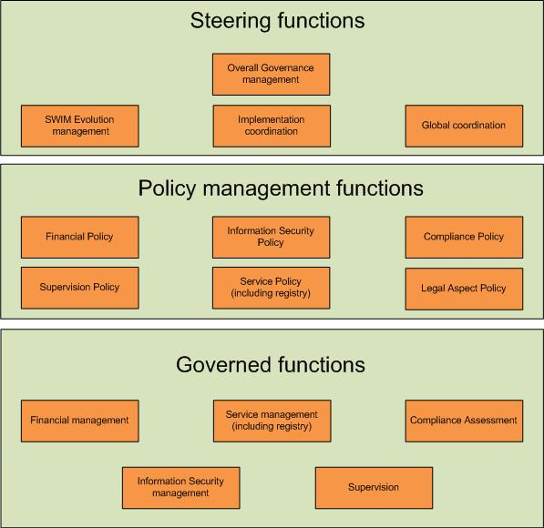
Figure 1 – IM Functions

Figure 1 ‘groups’ the IM Functions in ‘steering’, ‘policy management’ and ‘governed’ functions. The ‘steering’ IM functions are the functions that guide and steer the SWIM evolution. They also cover the actual overall SWIM governance process. The ‘steering’ IM functions have a direct influence on the ‘policy management’ and ‘governed’ IM functions.
The ‘policy management’ functions make policies for the areas covered by SWIM services (financial, compliance, supervision, etc.).
The ‘governed’ IM functions are classified as such because their scope is defined / delimited by the ‘steering’ and ‘policy management’ functions. They apply to both functions provided as common components and to the ones provided at the service provider level.
The following aspects must be clearly understood about the depiction of IM Functions in Figure 1:
- It is assumed that service providers will implement their own ‘IM Functions’ (i.e. governance) related to the services (and information) they provide. Therefore, it is expected that they will put in place appropriate Change, Fault, Performance and Security management mechanisms etc. In the SWIM context, the IM Functions classified as ‘governed functions’ represent just the IM functions that are ‘driven’ (or impacted) by the ‘steering’ and ‘policy management’ functions.
- Therefore, this document does not cover any ‘local’ IM Functions that need to be specifically addressed by service providers. ‘Local’ in this context refers to IM Functions at service provider level that are not impacted by any ‘steering’ or ‘policy management’ IM function.
- The actual scope of the IM Functions is subject to agreement by the affected stakeholders. Indeed, while this document provides a first description of the IM Functions, their actual scope when deployed may need to be further refined by the entity responsible for the SWIM deployment management in collaboration with the relevant stakeholders. Appendix B provides a proposal for IM Functions ‘tailored’ to the PCP / iSWIM deployment.
As stated before, the purpose of the document is to define ‘what’ is needed as governance (i.e. the IM Functions) and neither ‘who’ provides them, nor ‘how’ they are provided. Nevertheless, Appendix D provides just for information a mapping between the defined IM functions and a governance structure proposed in the SWIM CONOPS document (ref. [1]).

IM Function Descriptions

Steering Functions

Overall Governance Management
Description.
This is a transversal function affecting all other IM Functions and oversees the operational and strategic development of SWIM.
It is the root of all IM functions, it defines who (entity, group) is responsible to execute the other IM functions if not already defined in an agreed SWIM Governance structure. It defines the roles and responsibilities of all SWIM governance bodies and ensures transparency on the decision making process.
It is responsible for setting and supervising the strategy, policy, principles and common procedures for the SWIM Governance. This function is the decision making function for general topics which have a broad technical, strategic, political, financial or/and organisational impact.
In this respect it identifies and establishes the relevant decision bodies to perform change management on the various elements that build the SWIM Foundation, standards & guidelines.
Its purpose is to ensure that SWIM Governance is fulfilled properly, i.e. it does what it is supposed to be doing, detects shortcomings and defines corrective actions that need to be implemented. It also steers SWIM Governance overall to adapt to changing conditions.
The function acts on audit results and reports that are required by the different policies, and checks whether set performance goals are achieved, based on SWIM principles that have to be respected.
This function steers and provides direction in terms of:
- SWIM objectives,
- SWIM deployment strategy,
- The evolution and changes to the IM Functions and the overall SWIM governance arrangements (Bodies, Processes, etc.)
- Budget and decisions involving large expenditures.
The “Overall Governance Management” function contains activities on
- Policy Management
  - Endorse the policies that are defined and updated by the policy functions and provides policy guidance.
  - Initiate changes to SWIM Policies and SWIM Standards.
- Governance directives
  - Ensure that the various initiatives, carried out by the governance groups, pertaining to the evolution of SWIM artefacts are aiming at the same direction.
  - Ensure an appropriate process to handle requests for the evolution of SWIM, expressed by stakeholders e.g. when defining or implementing a new service.
  - Endorse governance process descriptions, governance templates and other governance related artefacts.
  - Set and maintain the Terms of Reference of the various SWIM Governance bodies.
  - Provide overall directions to the SWIM Governance bodies.
  - Declare and endorse the publication of SWIM Foundation, SWIM Standards and SWIM Common Infrastructure and provide directives for the SWIM Foundation evolution.
  - Define and maintain SWIM strategy (SWIM communication, SWIM capabilities (e.g. SWIM Registry), SWIM governance) in order to set appropriate priorities.
  - Provide directives on the operation of SWIM (e. g. SWIM Common Infrastructure Services).
- Decision Making
  - Take over the final escalation role in case of disagreements concerning the implementation of changes to SWIM Capabilities.
  - Ensure that decisions are based on the best available expertise and supported by appropriate rational.
  - Initiate proposals for the evolution of the SWIM Foundation, SWIM Standards as well as SWIM Common Infrastructure Services.
Rationale.
If this function were not implemented, there would be a high risk of SWIM Governance deviating from its intended purpose and not fulfilling its role. This in turn could have an impact on SWIM operations and on the SWIM concept itself.
Input required.
Audit results and reports produced by other IM Functions as required by the different policies.
Output.
- Steering decisions (e.g. implement or cancel a ‘SWIM common component’, request a policy update, etc.)
- Direction on SWIM objectives, deployment, evolution, changes to the IM Functions, budget and decisions involving large expenditures.
- Recommendations on SWIM standardisation
- ToRs for governance bodies
- Clearances for governance artefacts
- Signed final service contract documents
- High-level corrective actions
Dependencies with other functions.
As ‘overall governance management’ is an overarching aspect to be considered during all the governance activities, this function has dependencies with all other functions

Global Co-ordination
Description.
To ensure global consistency and compliance with all applicable rules and regulations, global coordination and standardisation in support of SWIM must be organised at the appropriate levels.

This concerns liaising with:
- International standards bodies (ISO, OGC, ESOs, EUROCAE, etc.)
- Regulatory bodies, e.g. ICAO, EU, EASA, FAA.
The liaison aims at assessing the potential impact on SWIM (e.g. on SWIM standards, compliance assessment, etc.) of various standardisation activities and regulations, whilst promoting the common European position on SWIM.

This function shall also co-ordinate at global level how the mutual recognition of compliance (criteria, means of compliance) will be handled between different SWIM implementations.

The “Global Co-ordination” function contains activities that

- provide input concerning the SWIM Standards and the SWIM Foundation from European and international committees and standardisation organisations in the case of a relation to SWIM,
- coordinate with appropriate European standardisation organisations on the SWIM Foundation and SWIM Standards,
- liaise with international organisations like the ICAO IM Panel and provide inputs linked to global coordination to the other governance bodies.

Rationale.
SWIM in Europe must not be isolated from other related initiatives and actors. The SWIM Governance Authority shall establish an IM Function responsible for the co-ordination with other bodies that can have an influence in the SWIM specifications / operations. Developments in such bodies need to be closely followed to determine what could have an impact on the European SWIM implementation in terms of standards, compliance rules, etc. The common European position should also be promoted to protect the European SWIM investments.
A number of risks exist if such a function were not implemented:
- Interoperability of SWIM standards with other regions.
- Divergence on standards evolution, which may create interoperability problems with other regions of the world.
- Additional costs due to uncoordinated standardization processes
- Ignorance of new regulations potentially impacting SWIM operations.
- Compliance overburden for services that are intended to be provided to consumers in different SWIM implementations (e.g. SESAR SWIM, NextGen SWIM).
- In addition, the function aims at ensuring provisions related to mutual recognition of SWIM compliance. The lack of such provisions would be detrimental to all SWIM providers, thus jeopardizing the whole SWIM concept.
Input required.
- ICAO Global Air Navigation Plan (e.g. ASBUs – Aviation System Block Upgrades);
- Dialogue through adequate global coordination arrangements in line with the aforementioned regulatory provisions;
- Applicable international standards.
- Regional SWIM compliance processes and criteria
Output.
- Contribution to global evolution planning, in particular the ICAO Global Air Navigation Plan (GANP)
- Recommendations on further work to be performed regarding standards evolution, implementation of new regulations, etc.
- Propositions of processes for mutual recognition of SWIM compliance
- Input for ICAO IM Panel and other international and European organisations

Dependencies with other functions.
- Overall Governance Management
- SWIM Evolution Management

SWIM Evolution Management
Description.
This function will provide the overall control for the SWIM standards and SWIM Common Infrastructure Services. It evaluates, approves or rejects change request to SWIM elements like the SWIM Foundation, SWIM Guidance Material and SWIM Standards.
It ensures that decisions on change requests are based on the best available expertise and are supported by appropriate rationale. It will make technical proposals and recommendations on SWIM matters and ensuring a consistent and coherent evolution on SWIM.
This function also ensures the provisioning and maintenance of governance related artefacts like compliance criteria, templates, etc. The function ensures the SWIM Change Management, whether the Change Control Board is established as an internal part of the SWIM Governance structure (e.g. ISRM CCB) or if there is a need to coordinate with external CCBs. The SWIM Evolution Management needs to ensure that the collective interests of the European SWIM deployment are represented in governance organisations of specifications and standards that are used but not owned by SWIM Governance (e.g. in “external CCBs” such as FIXM CCB,…). This representation may be ensured either through a coordination of the positions of the European members involved in these organizations or through a representation of the SEG as a new participant in these organizations.
This function covers several aspects on

SWIM Change Management (strategic)
- Establishing change control boards.
- Providing overall directions to the CCBs.
- Setting the priorities for the development of the SWIM Foundation, SWIM Registry and SWIM TI.
- Provide and maintain a SWIM Foundation Evolution Plan and SWIM Standards Evolution Plan.
- Ensuring a consistent evolution and changes to the SWIM Foundation Landscape [4], including the SWIM Foundation, the SWIM Standards and the SWIM Guidance Material,

SWIM Change Management (operative)
- Evaluate change requests and allocate to the appropriate internal or external CCB or CCBs.
- Manage the evolution of the SWIM Policies and SWIM Standards.
- Maintain the SWIM Governance Framework.
For “internal” CCBs
  - Run the CCBs
  - coordinate Communicate between CCBs and act as the escalation body in case of disagreements
  - Analyse Change requests and technical change proposals from SWIM users and provide recommendations to the relevant CCBs.
  - Review and approve the ToRs and procedures of the CCBs
  - Make decisions on updates/upgrades of ‘SWIM Common Infrastructure Components’ (e.g. SWIM Registry) and of SWIM standards (e.g. AIRM, ISRM).
  - Working on Change Request and provide technical solutions.
For “External” CCBs
  - Elaborate appropriate Change Requests
  - Organize the contributions either through liaison with the European participants, or through direct contribution.
  - Gather inputs from the CCBs meetings, analyse any decisions and evolutions affecting the European SWIM deployment.
SWIM Compliance Management
- Provisioning of the SWIM Foundation and SWIM Standards.
- Ensuring proper maintenance of SWIM Standards and the SWIM Foundation.
- Represent the highest escalation level in case of issues (e.g. compliance disputes).
Rationale.
Whereas Overall Governance Management covers the organisational aspects of SWIM governance, the SWIM Evolution Management covers the technical aspects. Without this function the evolution of SWIM could not be done in a controlled way.
Input required.
- Service design description documents
- Change Requests (including those made by the Global Co-ordination) and Service Lifecycle Management functions
- Existing Foundation Material
Output.
- Updated AIRM / ISRM models
- SWIM Architecture definitions (SOA models, technology selections, SWIM profiles, etc)
- Updated SWIM TI specifications
- Updated Compliance Framework (templates, )
- CR approvals and the reporting on CRs.
- SWIM Foundation Evolution Plan
- SWIM Standards Evolution Plan
- SWIM Governance artefacts (as parts of the foundation)
Dependencies with other functions.
- Global Co-ordination
- Service Management

Implementation Co-ordination
Description.
This function will perform impact analyses of change requests if it is anticipated, that there will be a great influence on the current operations which requires an overall co-ordination for their implementation.
This coordination may relate to SWIM TI, SWIM Common Infrastructure Services, SWIM Service Descriptions and eventually SWIM Services Instances. For example, change requests that can influence the current operations by changing an operational service instance. The co-ordination will also be provided for compliance assessments.
The function will define appropriate transition plans and co-ordinate the execution of such plans and undertake the SWIM Problem Management.
This function will also ensure that maintenance plans are harmonised and co-ordinated and that they contain adequate provisions to minimise operational disruptions.
If conflicts between SWIM Users arise, this function will provide a mediator role.
The Implementation Co-ordination supports
SWIM compliance assessments
- analyse compliance reports and identify recommended actions,
- provide directives and support to accomplish compliance assessments,
- coordinate between the SWIM providers and the mandated assessor, when applicable as defined by the compliance policy,
- mandate assessors to perform compliance assessments, when applicable as defined by the compliance policy,
SWIM Problem Management
- determine technical solutions to SWIM user problem reports,
- process and escalate problem reports,
SWIM Implementation Co-ordination
- decide on the need for over-all coordination and coordinate from the approval of a change request until the final implementation,
- analyse and approve integration plans, integration documentation and test reports,
- perform impact analyses concerning the consequences of approved change requests,
- manage the implementation of the policies and standards provided by the SEG,

- conduct impact analysis of Change Requests related to planning and project management matters, notably identifying planning dependencies,
SWIM Contract Management
- produce and manage contracts and ensure that the expected service quality is met,
- monitor the SWIM service management between providers and consumers, i.e. monitor version change, deprecation, cutover dates etc.,
- maintain a record of the SWIM modification activities,

Rationale.
This function is required because there will be a need to implement changes at various sites across several stakeholders (at the same or different times) in a co-ordinated manner. If this co-ordination were not available, changes or maintenance interventions could lead to disruptions in the services provided.
Input required.
- Approved change requests
- Maintenance plans submitted by service / infrastructure providers
- Compliance assessment reports transmitted by SWIM providers
- Problem reports
- Integration plans and integration documentation
- Compliance Assessment Reports
- Test reports

Output.
- Co-ordination plans and Transition plans
- proper co-ordination of implementation activities
- Compliance assessment reports
- Impact Analyses reports
- In case coordination is required: Project Management outcome (e.g. Schedules, meeting minutes, …)
- Service Contract Definitions (e.g. SLAs)
- Problem Solutions
- Approved Compliance Assessment Reports
- Transition plans

Dependencies with other functions.
- SWIM Evolution Management
- Service Management (for the Registry part)

Policy Management Functions
Definition: A SWIM Governance Policy groups a coherent set of rules and principles on certain cases of governance to steer decisions and achieve rational outcome. Thereby it makes the operation of the SWIM Governance deterministic. It sets the framework, in which the SWIM Governance Processes are defined.

Financial Policy
Description.
This function manages (defines and updates) the financial policy related to funding and charging in terms of:
- SWIM Governance structure
- Provision and operation of SWIM Common Components and Services
- Compliance assessment activities
- Potentially the provision, upgrades and operation of infrastructure and services by service providers.
- Potentially required auditing activities
- etc
Rationale.
Financial policy management is required to give every stakeholder a transparent picture of the cost situation, the charging scheme and funding provided for the SWIM governance, SWIM Common Components and Services.
Input required.
- Governance structure
- Inventory and scope of SWIM Common Components and Services.
Output.
- Financial policy documents
Dependencies with other functions.
- Service Management
- Service Policy
- SWIM Evolution Management
- Implementation Co-ordination

Information Security Policy
Description.
The function provides (defines and updates) the information security policy applicable to SWIM. The information security policy provisions shall be proportional to security requirements.
A policy is required to cover the SWIM needs (in terms of Confidentiality, Integrity, Availability, etc.), the way the security policy is applied (e.g. enforcement by an ‘independent’ organization, on a voluntary basis, etc.), the audits that are needed and the way they are performed (e.g. by external ‘independent’ auditors, internally, etc.), the common security-relevant services accepted by stakeholders, etc.
The security policy:
- shall identify the roles and responsibilities in their application.
- may be limited to provisions already referenced in existing regulations and thus not require additional provisions by service providers or the implementation of SWIM Common Components.
- may additionally define a Security Framework including a stringent security policy based on a set of criteria (service consumer, requested service, unclassified/confidential/military/.. data, etc.) and eventually SWIM Common security Components. This Framework may include, inter-alia:
  - High level principles to be respected like equal right of access for all stakeholders, compliance with EU privacy protection rules.
  - A Security Risk Assessment Method to be applied.
  - Procedures to be established for user authentication.
  - Authorization criteria and process, including escalation procedures in case of disagreements.
  - Authorities accredited to check authentication of individuals.
  - Confidentiality and independence requirements through the authentication and authorization processes.
  - Other controls to be applied for the Confidentiality, Integrity, Availability and other security needs.
  - Roles and responsibilities, clarifying the relationship between security management oversight and runtime security.
  - What sort of security audits, if any, should be performed on services, infrastructure, service providers, SWIM Common Components, etc., as well as the responsibilities for such audits
- may address security exceptions to be granted e.g. linked to national limitations.
- may be made specific for different types of service depending on e.g. different operational safety requirements.
Rationale.
If a common security policy were not available, different service providers could consider different security policies, which would be detrimental to the required interoperability, consistency and the overall level of security.
Input required.
- Applicable regulations from ICAO, EU and other organizations
Output.
- Information security policy document
Dependencies with other functions.
- As security is an overarching aspect to be considered by all governance activities, this function is interdependent from all other functions.

Service Policy (including Registry)
Description.
This function manages (defines and updates) the Service Lifecycle policy, including the Registry policy. The service lifecycle comprises several steps that a service needs to traverse from its inception to its deprecation (see also chapter 3.3.5).

It defines all artefacts required to be produced during a service’s lifecycle and provides appropriate guidelines and rules to be applied (e.g. foundation material, templates).

The service policy may vary for different types of services (e.g. non-safety critical, safety critical, etc.).

It is not in the scope of SWIM governance to stipulate how a provider manages his service lifecycle process (SLMP) as long as the level of quality of the artefacts he produces complies with the intended compliance level. The Service Lifecycle policy can propose the specific milestones and the associated artefacts that mostly also constitute a gate in the transition from one major lifecycle step to another (see Figure 2). The SLMP example hereunder is provided for a better understanding, it is not intended to be the mandated process for service providers.

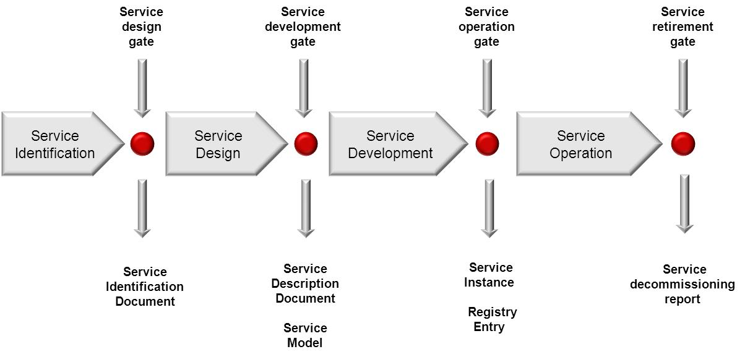A common infrastructure service and its process description(s) is fully under control of the SWIM governance authority and therefore those processes are a part of the and might be also part of a service contract and therefore be used as a means of compliance to determine and benchmark the service quality.

As the SWIM Registry is considered as a service provision (although a special case, i.e. a SWIM Common Component), the policy management regarding the Registry is considered to be part of this IM Function. Nevertheless, the Registry service has some specifics that will not be covered by ATM service lifecycle policy.

Therefore, this IM function will define for the Registry Policy, inter alia:

- the split between a central and local registries
- the interaction, if required, between the various registries,
- the details on the recognition of registration between various registries
- the entity(ies) running and controlling the registry(ies)
- the quality of service of the registry operation
- the security aspects, including confidentiality to be taken into account by the service manager function, the criteria for the assignment of access rights to SWIM stakeholders (providers, consumers, infrastructure providers), the cases leading to revoked access, data protection, etc.
- the procedure leading to removal of services from the registry
- the registry metadata about services
- the service provider taxonomy

Rationale.
The service policy ensures that the right information is provided for service identification, definition, discovery and consumption.
The artefacts produced in the execution phase of the Service Management function at the provider level (e.g. service models, service instances) will be assessed by the Compliance Assessment function. Therefore, it is essential that they are consistent and complete and adhere to the guidelines and rules stipulated by the Service Policy Management as well as the Compliance Policy Management function.
Input required.
- Existing material from SESAR
- Service Requirements
Output.
- Service Policies (Service Lifecycle and Registry policies)
- Foundation material, templates, guidelines, etc.
Dependencies with other functions.
- Financial Policy
- Compliance Policy
- Global Co-ordination
- Service Management (including Registry)

Compliance Policy
Description.
The function manages (defines and updates) the SWIM Compliance Principles and Criteria (on the basis of existing SWIM Compliance Principles and Criteria documents).

This Compliance policy may cover items (objects under assessment) such as service definitions; service Instances, SWIM infrastructure (e.g. SWIM nodes) etc.

An example for the compliance policy is provided in Appendix E.

It defines:

- How compliance is assessed (e.g. self-assessment, assessment by an independent testing institute, use of a Common Service for compliance assessment) and its relationship with existing regulation bodies (e.g. NSA, EASA) as appropriate.
- High level principles to be respected like e.g.:
  - Ensure that, in the case of service provision, the data / information provided is fit for purpose and fulfils the applicable regulations (e.g. personnel qualification, quality management)
  - Ensure there will be no impact on operational systems during the compliance assessment.
- The Compliance Criteria, i.e. what are the compliance artefacts to be produced for the SWIM Compliance assessment,
- The escalation process (the last escalation level will be referred to the Overall Governance management function).
The compliance policy shall be adapted to various configurations:
- The compliance policy (criteria and compliance assessment) may be different for the different types of objects under assessment covered (e.g. a service definition or a service instance)
- The compliance policy (criteria and compliance assessment) may be different for the different types of services (e.g. non-safety critical, safety critical, etc).
- The compliance policy (criteria and compliance assessment) may be different for different stakeholder groups (e.g. States, ANSPs, private sector companies)

The compliance policy shall include the compliance arrangements with other SWIM implementations (co-ordinated through the Global co-ordination function).

Rationale.
The SWIM compliance policy allows consumers to trust in SWIM services meeting agreed standards. If the Compliance policy function were not implemented, it would not be possible to establish different levels of compliance in an authoritative way.
Input required.
- Existing SESAR material (SWIM compliance documents, SWIM ConOps, …)
- SWIM architecture definitions (AIRM/ISRM models, technology selections, SWIM profiles, etc.)
- Rulebooks, guidelines
Output.
- Compliance Policy documents (Compliance Principles, Compliance Criteria).
Dependencies with other functions.

- Global Co-ordination
- Service Policy
- Service Management
- Compliance Assessment
- SWIM Evolution Management

Supervision Policy
Description.
The function manages (defines and updates) the SWIM Supervision policy. It may cover, inter alia, the need for SWIM Supervision (e.g. Configuration Management, Fault Management, Performance Management, etc.) at various levels, which may be local, FAB/sub-regional and/or the European level (e.g. through the use of a Common Service).

In the specific case of Performance Management, this policy may cover requirements on performance definition and monitoring, independence of the body that provides the performance monitoring (how is this ensured?, who is responsible to perform the monitoring?), distribution of monitoring results, provisions in case of no compliance with specified targets, etc.
Rationale.
The required level of Supervision for the SWIM environment at various levels (e.g. local, FAB/sub-regional and/or European level) needs to be defined (if any). If such a definition were not done, only uncoordinated instantiations of local Supervision would be available and there would be no way to verify SLA fulfilment ‘independently’.
Input required.
- Service definition SLAs
Output.
- Supervision Policy document
Dependencies with other functions.
- Supervision

Legal Aspects Policy
Description.
This function manages (defines and updates) the SWIM Legal Aspects policy. It may cover, inter alia:
- Handling of copyrighted service interfaces (in the case the corresponding services are deemed necessary on SWIM).
- Definition of the SWIM participation policy and the associated formal registration procedures (for consumers, providers of services). It defines who (entity, group) is responsible to implement this participation policy if not already defined in an agreed SWIM Governance structure.
- Ownership and liability policy in general, and more specifically:
  - in case of re-use of information.
  - Liability in case of accident or incident due to a SWIM component failure.
- Intellectual Property Rights policy, also including the definition of mechanism to co-ordinate and arbitrate IPR issues across borders and boundaries, taking due account of national legislations. This includes the licensing framework for the use of the AIRM and ISRM.
- Limitations to the use of some data.
- Definition of a legal framework for SWIM incident analysis / investigation, if any, taking into consideration cross-borders aspects. This framework shall define roles and responsibilities. It shall also cover the follow up of investigation results and enforcement of remedial actions by the Overall Governance management function.
This policy shall also define the entity(ies) responsible to ‘enforce’ it and the way such ‘enforcement’ will be performed.
Rationale.
With the implementation of SWIM, the legal aspects related to IPR, incidents that could happen due to SWIM, etc. should be addressed.
Input required.
- Existing European and national laws.
Output.
- Policies detailing the legal aspects.
Dependencies with other functions.
- -

Governed Functions

Financial Management
Description.
This function will implement the actions set out in the Financial Policy. These can include, inter-alia:
- Financing related to SWIM governance.
- Financing of the provision and operation of SWIM Common Components and Services (e.g. the common Registry).
- Accounting according to the Financial Policy.
- Potentially financial actions (charging) related to the provision and operation of infrastructure and services by Common Service providers (e.g. like PMU in PENS), if so tasked by the financial policy.
Rationale.
Should SWIM deployment require a number of elements to be funded by the SWIM community (for example the Registry) a function is required to discharge the associated financial management responsibilities.
Input required.
- Financial policy document
Output.
- Financial management actions
Dependencies with other functions.
- Financial Policy

Information Security Management
Description.
This function implements the Information Security Policy through concrete actions. It covers all SWIM related components and infrastructures on the service provider side.
Examples for components covered by this function are:
- SWIM nodes
- User access databases
- Firewalls
This function is also responsible for implementing and maintaining the common information security services specified in the Information Security Policy.

Several examples of potential common information security services (their deployment depending on the Information Security Policy):

- Provision and operation of a PKI as a SWIM Common Component including the capability to issue digital certificates to stakeholders, revoke certificates, issue certificate revocation lists, etc.
- Provision and operation of a bridge PKI as a SWIM Common Component to bridge between PKIs operated by different stakeholders.
- Common procurement of a security audit service required by the Security Policy for all or a group of service providers.

Rationale.
Every connection to the common SWIM infrastructure represents an opening of SWIM with a potential risk of intrusion and attack. Therefore, specific security provisions must be implemented by this function to safeguard against malicious actions.
Input required.
- Information Security Policy document
Output.
- Secured SWIM infrastructure components on provider site
- Provision of an agreed information security Common Service
Dependencies with other functions.
- Information Security Policy
- Financial Management

Supervision
Description.

This function implements the tasks defined by the Supervision Policy. The scope of this action could range from:
- Nothing to be done.
- Just producing a number of periodic reports and submitting them to a higher level of supervision
- Implementing specific supervisory task related services to provide supervision information to a higher level of supervision.
- Implementing specific supervision related services to allow control (the level of control should be defined) from a higher level of supervision.
- Providing a consolidated European level supervision as Common Service, in case the Supervision Policy indicated that there was a need for supervision at European level (even if it was just to consolidate reports received from the Local or sub-regional levels).
Rationale.
If an agreement is reached that supervision of SWIM at regional level is needed, there could be a requirement for this function. This function could be needed to implement specific supervision related services to allow an independent monitoring of the actual QoS being offered. Supervision at the European level could also be necessary to appropriately handle events that require overall co-ordination, such as cyber-attacks. Such a European level supervision needs to closely collaborate with local level supervision.
Input required.
- Supervision Policy document
Output.
- The output would depend on the scope assigned to the function. It could potentially include SLA reports, problem solving and co-ordination actions, …
Dependencies with other functions.
- Supervision Policy
- Financial Policy

Compliance Assessment
Description.
This function assigns the performance of compliance assessments as defined by the Compliance Policy Management function to service providers. These compliance assessments may mean executing tests available from third parties and furnishing such test reports as proof of compliance. They may alternatively mean that a formalized certification process needs to be undertaken by the service provider.
This function performs the compliance assessment actions, if such actions are defined in the Compliance Policy document.

- As a minimum, this function is supposed to cover the reception and analysis of compliance assessment reports before awarding the corresponding compliance level and entering this information in the Registry.
- Eventually, this function could also cover a much broader scope: from performing the actual assessment (i.e. executing a number of predefined tests/audits) to the implementation and maintenance of appropriate test suites for different service definitions.

Rationale.
The Compliance Assessment function is needed to certify services as “SWIM compliant” in an agreed manner. If not implemented, stakeholders will not be able to identify truly SWIM compliant services.
Input required.
- Compliance Policy document
Output.
- Compliance assessment report
- (Self)declarations of compliance
Dependencies with other functions.
- Compliance Policy
- Financial Policy
- Service Management

Service Management (including Registry)
Description.
In the scope of this function the activities in conjunction with the Service Policy as well as the Compliance Policy concerning the infrastructure and services provided by service providers are performed. For example in case a service provider would like to implement a new service instance, the aforementioned policies will indicate what actions and artefacts need to be performed/created to put the new service in operation at any given compliance level.

This function shall define the implementing / transition plan to put a service into operations. It shall also define provisions addressing the potential interdependencies with other services.
The service provision has to be offered according to the service quality following the agreed service contracts (e.g. service level agreements). As a prerequisite for offering SWIM Services, the SWIM Service Providers have to be qualified as SWIM Providers.
The quality of the service delivered by the SWIM Providers will be defined by service contracts (including Service Level Agreements), normally handled in a direct provider – consumer relationship. For the relationship between providers of SWIM Services and their consumers it is crucial that the contracts follow the recommended principles of the SWIM Governance.

This function contains activities to

- Offer SWIM Information Services following the rules and guidelines provided by the SWIM Service Policy and further applicable documents.
- Offer SWIM Common Infrastructure Components following the rules and guidelines provided by the SWIM Service Policy and further applicable documents.
- Perform the service lifecycle in accordance to the SWIM Service policy, if needed define an integration and transition plan to put a service into operations. It shall also define provisions addressing the potential interdependencies with other services.
- Maintaining all information related to services in the Registry including Service Definitions, when updates or new service definitions are required, and Service Instances. Depending on the type (Service Definition vs. Instance) different attributes (to be defined in the Service Lifecycle Policy) will have to be maintained.
The service management for the registry could cover, inter-alia, the following aspects:
- Maintenance of other information stored in the Registry related to e.g.
  - The list of SWIM standards
  - Reference documents
  - SWIM participants (consumers and providers): handling of registration requests, definitions in the registry, allocation of appropriate access rights, etc.
- Other administration tasks concerning the information stored in the Registry. Such tasks could be cleaning up, Handle registration requests, definitions in the registry, allocation of appropriate access rights, etc.
- Technical maintenance of the registry infrastructure such as the implementation of upgrades or changes mandated by the SWIM Evolution Management function.

Rationale.
A governed service lifecycle ensures a common approach to service development across SWIM stakeholders and helps to reach a defined level of quality.
The proper operation of the Registry and the maintenance of the information contained therein are required in a SOA environment in order to allow Service Consumers to find out which services are offered by service providers, to manage dependencies between services and thus determine the potential impact of changes to services, etc.
If the Registry service management function were not deployed, the benefits that SWIM could bring could not be exploited to their full potential - or at all. Furthermore, it would very likely render the task of the Implementation Co-ordination function impossible. This situation would worsen as the number of consumers, providers and services instances grow.
Input required.
- Service Lifecycle Policy
- Compliance Policy
- Change Requests from the SWIM Evolution Management
Output.
- Service definitions
- Service Instances
- Service Models
- Registry entries
- Service decommissioning report
- Integration /Transition documentation#
- Reports on Implementations of CRs and problem solutions
- Test Reports
Dependencies with other functions.
- Service Policy
- Compliance Policy
- Implementation Co-ordination.
- Financial Policy

Interactions between the IM functions
This section intends to be a proof of concept for the IM Functions.
Therefore, this section provides a number of governing processes showing the interactions among the IM functions listed before.
The purpose is to illustrate and ensure the completeness and consistency of the IM Functions by looking at the most significant governing processes. The definition of these processes needs to be based on the agreed way the SWIM stakeholders will interact among them to provide and consume SWIM services.
The governing processes need to be aligned with the governance use cases described in the SWIM ConOps [1], in its SWIM Use Case timeline section (the corresponding figures present in the SWIM ConOps are copied here below).
Therefore the following steps are provided within this section
- Mapping between use cases of the SWIM Conops and governing processes
- Mapping of IM Functions to governing processes
- A sequence of IM Functions to accomplish the governing process

Governance Use Cases

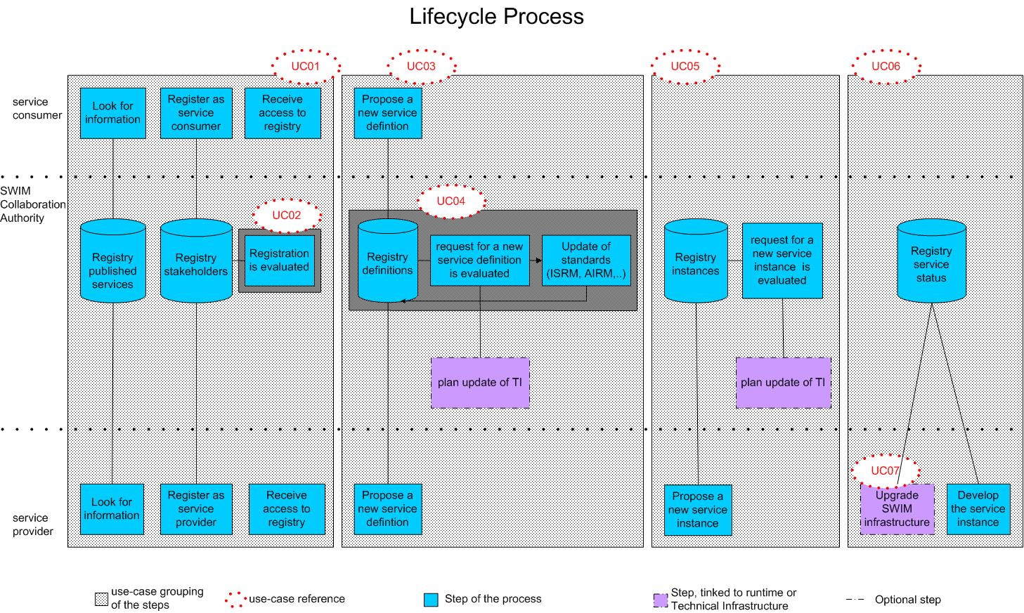
Figure 2 – Use cases part 1

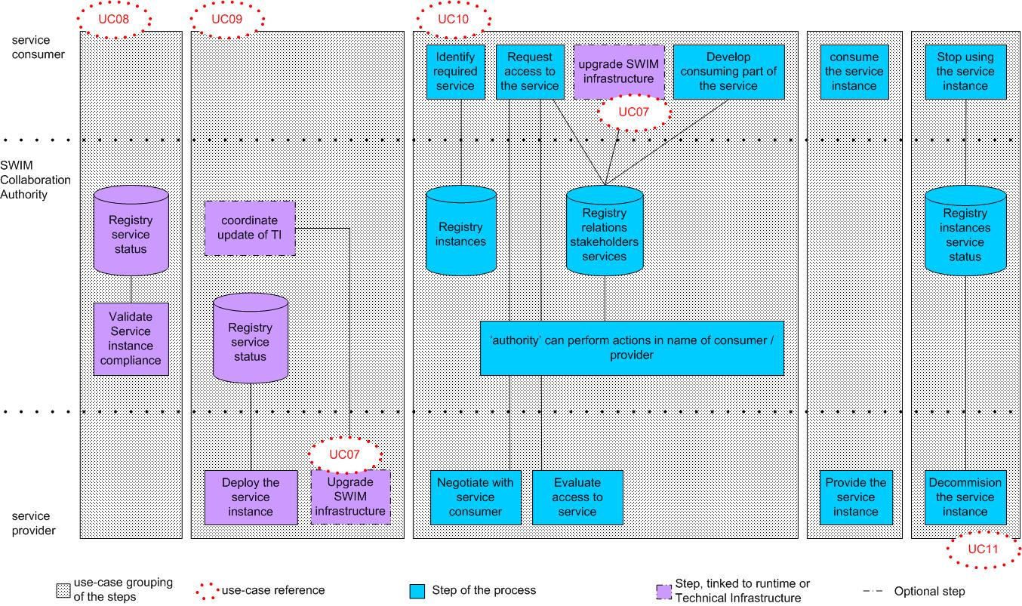

Figure 3 – Use cases part 2

The detailed description of the Use Cases is done in the Appendix A of this document.
The definition of the processes showing the interactions among the IM functions is adapted to these Use Cases. The following list (Figure 5) gives an overview of the relations between the Use Cases of the SWIM ConOps and the governing processes. If for a use case no process can’t be found it is indicated that a process is missing, if for a process no use case available, the process is not needed.

SWIM Governing process | SWIM ConOps Use cases
SWIM Service Design Management Process | UC03; A stakeholder proposes a new or upgraded service definition
SWIM Service Deployment Management Process | UC05; A provider proposes a new or upgraded service instance  UC06; A provider develops a new service instance  UC08; The “SWIM Governance Authority” / provider assesses the compliance of a service instance UC09; A provider deploys a new or upgraded service instance on SWIM  UC11; A provider decommissions a service instance on the SWIM infrastructure.
SWIM Standards Management Process | UC04; The SWIM Governance Authority manages the lifecycle of the reference models  UC07; A Stakeholder upgrades the SWIM infrastructure  UC12; The SWIM Governance Authority deprecates a service definition
SWIM Stakeholder Management Process | UC01; A stakeholder joins SWIM  UC02; The SWIM Governance Authority assesses a stakeholder

Figure 4 – Relations between the use cases of the SWIM ConOps and the governing processes
UC 10 (A consumer prepares to use an existing service via the SWIM infrastructure) is not in the scope of a governing process and therefore not listed here.
It has to be stressed that the Use case timeline and the processes are two different views of the same subject. As such, these two views are consistent but they are not the same, so there are a number of differences, as e.g.
- The Use cases detailed description provides low level details that are not present in the processes.
- The process for the SWIM standards management covers a scope larger than what is covered in the Use cases. I.e., the Use cases (mainly UC04 and UC07) are limited to changes triggered by ‘internal’ events, while the process also encompasses changes triggered by ‘external’ events (e.g. changes stemming from ICAO or EU regulations).
- The Use cases do not consider financial aspects explicitly as they are considered in the processes.
It is worth noting that the effort needed to execute supporting functions like the Implementation Co-ordination or Compliance Assessment very much depends on the actual impact a change might have on the overall SWIM system. An implementation plan which is one of the outcomes of the Implementation Coordination might vary from just stating that the provider is free to implement the change whenever he wants and that no further consultation is required (in this case an implementation plan might not be needed at all) to extensive transition planning, a detailed time scale and a requirement for comprehensive coordination and approval. The compliance assessments may also vary from a brief verification of the artefacts provided done on a self-assessment basis to a series of comprehensive predefined test cases. It is not in the scope of this document to give a detailed description of how these activities are to be done. This document merely outlines the overall tasks that need to be accomplished to ensure proper governance. The “how” will be defined in the respective policies.
It is important to note that the SWIM Governance Authority role could in certain cases be delegated to the provider. For example the implementation plan could be produced by the service provider taking on the SWIM Governance Authority role and executes parts of the Implementation Co-ordination IM Function.
Information Security Policy is not explicitly mentioned since it has to be considered by every IM Function executed during the governance processes anyway.

Governing Processes
The processes provided within the chapter should be seen as “realistic” examples on a generic level. They are influenced by the experiences gained during SESAR 1 and the conduction of the SEMG. During the deployment process they need to be better elaborated and a lot more detailed. They themselves will be objects to be managed within the evolution management process.
The processes anticipate the future governance structure like it is proposed within Part A of this deliverable.
The governing processes’ relationships with the Registry and the information security management functions are not depicted to ease understanding.

SWIM Service Design Management Process
The design of a new SWIM service can be triggered by a stakeholder who has an information need, by a data provider or by a service provider.
The service design might be financed through public funding (e.g. in case of a mandatory service change due to regulations) therefore the Financial Policy needs to be taken into account.
The Service Lifecycle Management is the activity where the main part of the service design is accomplished.
Here we provide an example which is very similar to the process conducted within SESAR 1. It is very likely that within the future governance arrangements the process will look slightly different and the artefacts will have different names or e.g. will not even be artefacts but database entries to be provided at a certain point within the process to show evidence on compliance to path the gate from one process step to the other.
In addition the SWIM Evolution Management needs to approve the Change Request (CR). The respective artefacts will be checked for compliance with the according SWIM rules. The SWIM Evolution Management needs to take specific notice of the transition of service descriptions that are already instantiated. This process is depicted in Figure 6.

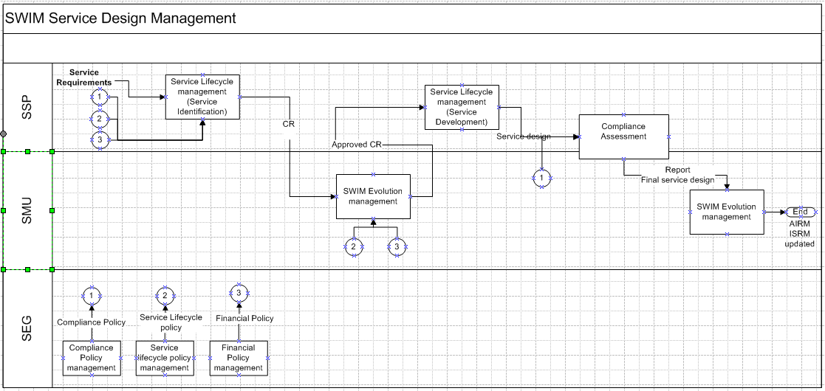
Figure 5 – SWIM Service Design Management Process

SWIM Service Deployment Management

Again the main part of the work will be executed within the Service Lifecycle Management on the provider side.

As the service instantiation represents a change in the “running system” the implications have to be assessed and in some cases (e.g. service instance decommissioning) an action plan has to be mutually agreed between the SWIM Governance Authority and the service provider.

An impact analysis report might be provided which could be used to define test cases for the compliance assessment activity (concerning Common Infrastructure Services as well as ATM specific services). The service instance documentation will be object under assessment.

The Financial Policy needs to be considered for the charging of the service. The process is outlined in Figure 7.

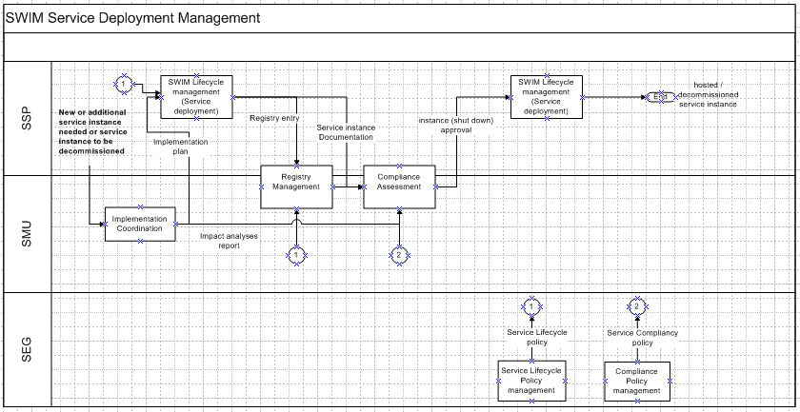
Figure 6 – SWIM Service Deployment Management Process

SWIM Standards Management
The governing process to handle changes to the ISRM triggered by 'internal' reasons is already described in section 4.1 SWIM Service Design Management.
This section deals with changes to 'SWIM standards' (refer to the SWIM Foundation primer for further information on the SWIM Standards [4]) caused by external factors. The Global Coordination function, which monitors the "outside world" for standardisation or regulatory activities with a potential impact on SWIM, would raise a CR when change that has an impact on the current 'SWIM Standards' is detected.
Other cases covered by this process are requests for change, updates to existing SWIM Common Components and the implementation of new SWIM Common Components or Services. For example the initial SWIM deployment might not foresee the Compliance Assessment Common Service. However, operational experience gained may point to a strong requirement for such a service. Then a corresponding CR would have to be raised to address the issue.
In both cases the CR will trigger the SWIM Evolution Management. If major changes are necessary approval by the Overall Governance Management is required. The SWIM Evolution Management function would then update the corresponding artefacts.
As changes to SWIM standards could have a big impact on the whole SWIM system, the Implementation Coordination function may not immediately develop an implementation plan. It could also initiate a call for tender in accordance with European procurement rules when appropriate. Large-scale changes may require a comprehensive compliance assessment and validation process before they are implemented in the live SWIM system. Figure 6 depicts this process.
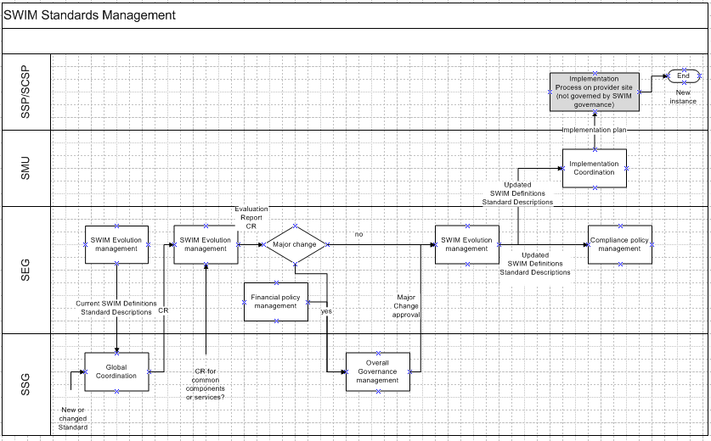
Figure 7 – SWIM Standards Management Process

SWIM Stakeholder Management

Two events could invoke this function: the registration of a new SWIM stakeholder or the (re-)assessment of a SWIM Provider. In both cases the Compliance Assessment IM Function is the main contributor to this process. After all preconditions are met the respective updates to the Registry are made by the SWIM Governance Authority. Figure 7 depicts this process.

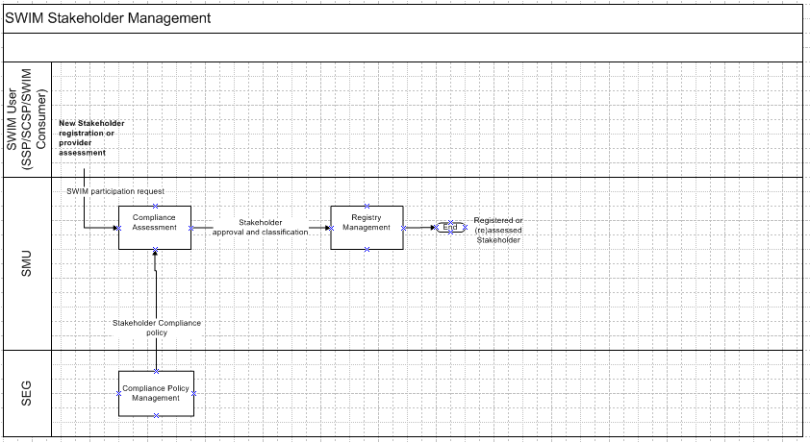

Figure 8 – SWIM Stakeholder Management Process

References

- 08.01.01 D42 – SWIM ConOps
https://extranet.sesarju.eu/WP_08/Project_08.01.01/Project%20Plan/DEL08.01.01-D42-SWIM%20conops.doc
- B.04.03-D81 SESAR Working Method on Services Edition 2013 https://extranet.sesarju.eu/intraprogman/Assessment%20Library/D81%20-%20SESAR%20Working%20Method%20on%20Services%20Edition%202013%20-%20released.doc
- 08.03.01 D14 Concept of Operations for SWIM Supervision https://extranet.sesarju.eu/intraprogman/Assessment%20Library/DEL08.03.01-D014-Concept%20of%20Operations%20for%20SWIM%20Supervision.doc
- 08.01.01 D51 – SWIM Foundation Primer https://extranet.sesarju.eu/WP_08/Project_08.01.01/Project%20Plan/D51%20SWIM%20Foundation/DEL08%2001%2001-D51-SWIMFoundationPrimer.docx
- 08.01.01 D48 – SWIM Compliance Criteria https://extranet.sesarju.eu/WP_08/Project_08.01.01/Project%20Plan/D48%20SWIM%20Compliance/08%2001%2001-D48-SWIM%20Compliance%20Framework%20Criteria.docx
- SDD Template https://extranet.sesarju.eu/Programme%20Library/SESAR%20European%20ATM%20Service%20Description%20Template.docm
- Service Technical Design Description (example EFPL submission FIXM) https://extranet.sesarju.eu/WP_07/Project_07.06.02/Project%20Plan/Trajectory-Step%201/BT%20Technical%20Specification/VP-713%20Extended%20Flight%20Plan/STDD%20and%20Related%20Material/SESAR%20Service%20Technical%20Design%20Description_EFPL_Submission%20FIXM.xlsm
- SWIM Governance Structure
https://extranet.sesarju.eu/WP_08/Project_08.01.01/Project%20Plan/D47%20SWIM%20Governance%20Structure%20and%20IM%20Functions/DEL08%2001%2001-D47-SWIM%20Governance%20Structure.docx

- Detailed Use Case definition

It is reminded that this detailed description is just a proposal based on a number of assumptions listed in the SWIM ConOps document. Therefore, the actual SWIM deployment might differ from them.

  - Uc01 A Stakeholder joins SWIM

Use Case |  | Uc01 stakeholder joins SWIM
Description |  | Before a stakeholder can join SWIM, the stakeholder needs to be registered. In order to do that, the stakeholder provides the necessary information as defined / required by the SWIM Governance.  The registration of SWIM Stakeholders can be performed at the level of an organisation, and / or at the level of an individual.
Primary Actor |  | SWIM service provider registers to  - access the private part of the registry,  - provide services on SWIM.  SWIM service consumer registers to  - access the private part of the registry,  - subscribe and consume services available on SWIM.
Supporting Actors |  | “SWIM Governance Authority”  - Defines the set of rules for who (as a company, as an individual) is allowed to access SWIM (criteria for accessing SWIM as a consumer or provider).  - Defines the attributes to be provided during registration.  - Provides a registration service for the stakeholders to register  - Analyses the request for access to SWIM  - Classifies the stakeholders of SWIM  - Keeps track of all SWIM stakeholders in the SWIM registry
Preconditions / assumptions |  | - It assumes that only registered stakeholders (service consumer / service provider) can access the resources available on SWIM.  - The SWIM registry has a public and private part. When the provider agrees and if no security conditions apply, the public part provides a high-level description of what is available in the private part. Only registered users can access the private part, provided they have the proper authorisation. The public part is accessible through the Internet by everybody.  - The SWIM registry contains information (e.g. service descriptions, standards, policies, compliance assessment results, regulations …) that is only available after registration (i.e. information in the private part of the registry). At this stage the registry is considered as a Common Service that is available as part of the SWIM concept.  - This use-case concerns only registration (an additional request to access a service is another use-case)
Basic flow
- The use case starts when the stakeholder (service consumer / provider) submits his request to be registered in the SWIM registry. This is done through the registration service (e.g. web registration form) which is operated by the “SWIM Governance Authority”.
- The stakeholder provides an initial set of attributes that were previously defined by the “SWIM Governance Authority”.
- The “SWIM Governance Authority” analyses the request and performs the necessary administration in the SWIM Registry.
- The stakeholder gets a confirmation and authorisation to the SWIM private part of the registry or refusal to access the SWIM registry (alternative flow # 1).
- The stakeholder receives the authorisation to the private part of the registry from the “SWIM Governance Authority” depending on the profile of the stakeholder (i.e. access control still applies, e.g. military information might only be available to military stakeholders).

Postconditions |  | The stakeholder has access to the private part of the SWIM registry and will be known as a member of SWIM.
Alternative flow #1
The “SWIM Governance Authority” refuses the access based on the attribute evaluation based on the rules were previously defined by the “SWIM Governance Authority”.

When refused, the stakeholder receives explanation of the refusal.
Postconditions | The stakeholder is refused access to SWIM.

  - Uc02 The “SWIM Governance Authority” assesses a stakeholder

Use Case |  | Uc02 “SWIM Governance Authority” assesses a stakeholder
Description |  | The “SWIM Governance Authority” needs to assess the compliance of a stakeholder on the SWIM infrastructure.  This needs to be done in the case of a service provider when:  - It is a new service provider;  - It provides a new type of services (see assumptions);  - Its previous compliance declaration has expired.  This needs to be done in the case of a service consumer when:  - To be defined
Primary Actor |  | - SWIM service provider who intends to provide a service or a set of services over SWIM
Supporting Actors |  | - “SWIM Governance Authority”  - Provides the rules for assessment and the escalation process in case of conflict in the result of the compliance assessment.  - Assess the provider request and issues compliance declarations  - Maintains the information on compliance declarations in the SWIM registry
Preconditions / assumptions |  | Applicable for service provider assessment. It is assumed that compliance assessment of service providers is required.  - The compliance assessment is done by the “SWIM Governance Authority”.  - The types of services ‘subject to compliance assessment’ / ‘not subject to compliance assessment’ have been identified.  - A general policy applicable to service providers has been defined. This policy encompasses the applicable regulations from NSA/EASA (e.g. such regulations might require a service provider to be certified by NSA or EASA).  - The role and the scope of work of the “SWIM Governance Authority” with regard to NSA/EASA has been agreed.  - The SWIM policies may need to make a difference between various types of providers (e.g. States vs. ANSPs vs. private sector)  - A specific policy applicable to the various types of services has been defined.  - The SWIM policies (general for those provisions applicable to all service providers and specific for those provisions attached to a specific type of service) needs to be explicit and backed by legal analysis  - The service provider is registered as a SWIM participant.  - A service provider can also be a service consumer of another service, e.g. parts of flight data are sent to ATM actors, but the ATM actors can then provide updates or new proposals for these parts of flight data.  - Certification procedures (at the level of NSA/EASA) and compliance procedures (at the level of “SWIM Governance Authority”) have been coordinated between the various regions. Mutual recognition of compliance assessment results have been addressed.  - When the service development and/or the service provision are outsourced to a third party, the implications in certification procedures / compliance procedures have been addressed.  - Legal aspects concerning escalation procedures and cases over compliance denials have been addressed.
Basic flow (for service provide assessment)
- A service provider requests to the “SWIM Governance Authority” to be allowed to provide (a) given type(s) of services (e.g. through a webform)
- The “SWIM Governance Authority” evaluates the request as follows:
  - Assess if the service provider meets the general policy (defined by the “SWIM Governance Authority”) that is applicable to all SWIM service providers (e.g. legal status, credentials)
  - Assess if the service provider meets the specific policy applicable to the type of service(s) requested (see Assumptions regarding the service ‘types’ that require compliance checking or not)
  - Requests a formal agreement (signature) of a “service provider agreement” which includes legal obligations (liability, copyright, charging, etc) as applicable and compliance with the applicable regulation (ICAO, SES, EASA/NSA).
- The service provider signs the formal agreements referred to in step 2.
- The “SWIM Governance Authority” grants the service provider a compliance declaration corresponding to the request, which includes termination / expiration conditions. This information is also maintained in the SWIM registry.
Note: in case of re- assessment, the same steps apply but the process may be eased by availability of previous compliance declarations.
Postconditions |  | The service provider is allowed to provide the type of service(s) detailed in the compliance declaration.
Alternative flow #1

Request from the service provider is refused by the “SWIM Governance Authority”.
Compliance denials are fully documented and backed by legal rationale (information provided by the “SWIM Governance Authority”).

Postconditions | - Service provider is denied access to SWIM, or denied the permission to provide a type of service(s).  - Escalation process in case of disagreement between parties over the interpretation of the SWIM general or specific policies.

  - Uc03 A stakeholder proposes a new or upgraded service definition

Use Case |  | Uc03 A stakeholder proposes a new or upgraded service definition
Description |  | A SWIM stakeholder wants to have SWIM extended with a new or upgraded service definition.
Primary Actor |  | SWIM stakeholder. Such new or upgraded service definition can be requested  - from a business perspective  - because it is imposed by regulation (ICAO, EC, EASA, …)  - based on a request from service consumer(s)
Supporting Actors |  | “SWIM Governance Authority”  - Provides the rules for the evaluation of the requests for new service definitions, e.g. data model compliance with AIRM) and the escalation process in case of conflict in the evaluation result .  - Checks the consistency of the proposed new service with the existing ones (is it redundant?).  - Assesses the changes that will be required to current standards, SWIM infrastructure, etc. if such new service definition is accepted.  - Decides on the acceptance/refusal of the request  - Launches the necessary processes to have the required changes (standards, SWIM infrastructure, etc.) performed if the request is accepted
Preconditions / assumptions |  | - The stakeholder making the request is registered as SWIM participant (uc01)  - This use cases (and others) makes reference to ISRM/AIRM. This shall be understood as the standards defining the data and service models as well as the interfaces, regardless as how these could be called after the SESAR program.  - When the Service upgrade is proposed (imposed) by the Collaboration Authority (e.g. to comply with new regulations), the associated costs with the services upgrade have been defined in a policy written by the SWIM Governance Authority.  - In case that a new service requires an update of the SWIM infrastructure, the SWIM Governance Authority will describe the process for the decision on accepting or refusing the new service definition (especially if this infrastructure update might impact SWIM Common Components or existing SWIM Nodes owned by stakeholders that will not be concerned by the new service).
Basic flow
- The SWIM stakeholder proposes a new service or an upgrade of an existing service. This is done through a request that is stored in the SWIM registry.
- The request is forwarded to the “SWIM Governance Authority” for evaluation.
  - If the proposed service is already in the ISRM or the established criteria indicates that the request shall be rejected, the SWIM stakeholder is informed that his request has been rejected (alternative #1)
  - If the proposed service is not in the ISRM, the “SWIM Governance Authority” assess the request for the new or upgraded service:
    - Safety and Security implications (for both providers and consumers)
    - Legal obligations (liability, copyright, evaluation of the charging policy, SLA (requirements for access are indicated) …)
    - Data Quality requirements (data source, data format - AIRM, consistency, timeliness, ...)
    - Service Quality requirements (ISRM, service technical interface, …) , constraints if any imposed at consumer side, consumer side constraints if any, “SWIM Governance Authority” constraints if any, QoS (performance, safety, security),…
    - Updates required in the SWIM infrastructure, if any, and their potential impact.
    - Compliance to the regulatory requirements (e.g. whether the service being proposed is compliant with the ICAO regulations)
- If the request is accepted, the SWIM stakeholder receives a positive evaluation. (or alternative #1)
- The SWIM registry is updated with this information, where the service status is set as ‘service under definition’.
- The “SWIM Governance Authority” launches the corresponding processes to have ISRM and eventually the AIRM updated accordingly (see uc04)
- If the new service will require updates in the SWIM infrastructure, the “SWIM Governance Authority” will agree and co-ordinate with the concerned stakeholders on an implementation plan for such updates.
- Subscribers receive notifications that a new service is ‘under definition’.
Postconditions |  | - The service definition is added to the ISRM  - Service providers can request the development of instances of such service (uc05)
Alternative flow #1
The “SWIM Governance Authority” refuses the service definition proposed.
Postconditions | - Escalation process in case the SWIM stakeholder does not agree on the refusal from the “SWIM Governance Authority”.

  - Uc04 The “SWIM Governance Authority” manages the lifecycle of the Reference Models (AIRM / ISRM)

Use Case | Uc04 The Collaboration Authority manages the lifecycle of the Reference Models (AIRM / ISRM)
Description | Both the AIRM and ISRM (Reference Models) are subject to changes and updates. The lifecycle steps to be taken into account are :  - definition  - development  - compliance assessment  - operation  - deprecation  The management of such lifecycle is under the responsibility of the “SWIM Governance Authority”. The SWIM Governance provides a mechanism whereby all stakeholders (service consumers, service providers and “SWIM Governance Authority”) with an interest in the Reference Models interact between each other in such lifecycle management.
Primary Actor | - “SWIM Governance Authority”  - Analyse CR  - Decide on CR  - Follow-up and implement CR  - Decide on release plan (exceptional interim releases)
Supporting Actors | - SWIM Stakeholder (e.g. service consumer, service provider, etc)  - Put forward CRs  - Take notice of new release  - Follow-up CRs
Preconditions / assumptions | - This use cases (and others) makes reference to ISRM/AIRM. This shall be understood as the standards defining the data and service models as well as the interfaces, regardless as how these could be called after the SESAR program.  - AIRM and ISRM follow the same process.  - At a given moment a Change Request (“CR”) has a single status (e.g. pending, approved, rejected etc.).  - The frequency of developing / approving / … publishing new releases has been developed by the SWIM Governance Authority (e.g. there could be some pre-defined release cycle for the Reference Models).
Basic flow
- Stakeholders issue / raise Change Requests (“CRs”).
- CRs are analysed by the “SWIM Governance Authority” which determines how to handle them + impact analysis (e.g. which of the logical / physical models are impacted).
- The “SWIM Governance Authority” follows-up and informs stakeholders.
- The “SWIM Governance Authority” takes decision and changes / administers the elements impacted (change of the model / translation of logical into physical).
- The “SWIM Governance Authority” performs/delegates quality control + approval.
- The “SWIM Governance Authority” publishes new release.
- The “SWIM Governance Authority” communicates a new release to stakeholders (consumers and providers).
- The “SWIM Governance Authority” coordinates the implementation of a new release.
Postconditions | A new release is available. If applicable, the planning for removal of deprecated services can be performed.

  - UC05 A provider proposes a new or upgraded service instance

Use Case |  | Uc05: A provider proposes a new or upgraded service instance
Description |  | A service provider wants to develop a new or upgraded service instance on SWIM. He needs an agreement from the “SWIM Governance Authority” before starting the development and before any deployment of a new (or upgraded) service on SWIM.
Primary Actor |  | SWIM service provider who intends to  - provide the service from a business perspective  - provide the service because it is imposed by regulation (ICAO, EC, EASA, …)  - provide the service based on a request from a service consumer
Supporting Actors |  | “SWIM Governance Authority”  - Provides the rules for the evaluation of the requests and the escalation process in case of conflict in the evaluation result. This means that there will be different authority levels within ‘SWIM Governance Authority’.  - Assesses if the provider is allowed to provide the service and issues compliance declarations.  - Maintains the status of the service (in the registry, …)
Preconditions / assumptions |  | - The service provider is registered as a SWIM provider (see uc01)  - The service definition is available in the ISRM.
Basic flow
- The service provider proposes a new or an upgrade of existing service instance. This is done through a notification that is stored in the SWIM registry.
- The notification is forwarded to the “SWIM Governance Authority” for evaluation.
- The “SWIM Governance Authority” evaluates the notification as follows:
  - Checks that the service provider has a compliance declaration to provide this type of service -see uc02- (e.g. legal checks, copyright of data being provided, compliance with applicable regulations …)
  - Advises on the conditions for the provision of the service for the provider (the ISRM contains these conditions in the service contract)
  - In case the proposed service instance is actually an upgrade of an existing service:
    - Impact on other services
    - The service provider has an transition plan
  - …
- The “SWIM Governance Authority” can request further details on the services and its compliance to applicable principles to the service providers. (or alternative #1)
- The SWIM registry is updated with this information, where the service status is set as ‘service under development/upgrade’.
- If the new service will require updates in the SWIM infrastructure, the “SWIM Governance Authority” will agree and co-ordinate with the concerned stakeholders an implementation plan for such updates.
- Subscribers receive notifications that a new service is ‘under development’.
Postconditions |  | The service provider can start the development of a SWIM compliant service instance.
Alternative flow #1
The service instance will not be accepted as SWIM Compliant.
Postconditions | Escalation process in case the provider does not agree on the refusal from the “SWIM Governance Authority”.

  - Uc06 A provider develops a new service instance

Use Case | Uc06 A provider develops a new service instance
Description | The provider develops a new instance of an existing ISRM defined service. I.e., it is assumed that either the ISRM already contained the definition of such service or the ISRM was already updated to include this service.
Primary Actor | SWIM service provider  - Develops the service instance  - Optional: Provides the means to verify the service in a pre-operational (test) environment
Supporting Actors | SWIM service consumer  - The service consumers who have subscribed to notifications from this provider are informed.  - The service consumers who requested this development are informed.  Optional: The service consumer participates to the pre-operational testing.
Preconditions / assumptions | - The service provider received the agreement from the “SWIM Governance Authority” to develop the service (provider has access to the data, data format is known, service interface is agreed, etc)  - The service description is available in the ISRM  - The service provider develops according to the SWIM standards (AIRM, ISRM)  - Optional: The provider has access to a test and pre-operational environment.
Basic flow
- The service provider develops the service instance.
- Optional: The service provider deploys the service instance in a pre-operation validation environment and performs testing with a limited number of selected service consumers.
- The service provider plans the needed actions to have the SWIM infrastructure under its ownership (e.g., upgrade it (uc07)) to be ready to support the developed service when needed. His SWIM infrastructure may need to be ready either for the service instance development, or for the compliance assessment of this service instance (uc08) or for the deployment of this service instance (uc09). This should be consistent with the plan agreed with the “SWIM Governance Authority” to update other SWIM infrastructure required, if any, to support such service (see uc03, uc05).
- The “SWIM Governance Authority” updates the registry (service catalogue); ‘subscribed’ stakeholders are informed about the development of the new service.
Postconditions | The service provider will have to request the “SWIM Governance Authority” to assess the compliance of the new service (see Uc08).

  - Uc07 A stakeholder upgrades the SWIM infrastructure.

Use Case | A stakeholder upgrades the SWIM infrastructure.
Description | This use case concerns the description of all the steps needed to upgrade or modify the SWIM-TI (e.g. configuration change or a new or updated capability).
Primary Actor | SWIM-TI Provider  - Provides the updated version of the SWIM-TI implementation under its responsibility / ownership.
Supporting Actors | “SWIM Governance Authority”  - Assesses the compliance of the updated SWIM-TI implementations when needed.  - Co-ordinates the deployment of such implementations among the concerned stakeholders.
Preconditions / assumptions | - The events triggering the use case come from registered SWIM stakeholders.  - The “SWIM Governance Authority”, as part of uc03 or uc05 or in a later stage, already evaluated and identified the changes in the SWIM-TI that were required and their impact:  - Just configurations changes of existing capabilities  - Implementation of a new capability  - Upgrade of an existing capability.  - The events triggering the use cases have been analysed and the “SWIM Governance Authority” agreed that either a configuration change in the existing SWIM-TI is needed or there are no existing SWIM-TI capabilities that are able (or that could be updated) to support the new requirements. Examples when upgrades or new capabilities could be needed are:  - One or several requirements for an existing ATM-specific service are modified or added and this requires a new SWIM-TI capability.  - A new ATM-specific service is defined and this requires a new SWIM-TI capability.  - During the SWIM-TI maintenance activities is identified a new capability that better supports ATM-specific services non-functional requirements.  - The “SWIM Governance Authority” has defined the SWIM-TI capability according to the required technical specifications (functional and non-functional requirements).  - The “SWIM Governance Authority” already agreed and defined a plan to have the SWIM-TI updated in a co-ordinated manner.  - The basic flow described below assumes that a new capability (or an upgrade of an existing one) will be required. The alternative flow described below assumes that just a configuration change of the existing SWIM-TI is required.
Basic flow

- The SWIM-TI providers develop the capability according to its specification.
- The “SWIM Governance Authority” assesses the compliance of the new or upgraded capability implementations from the relevant SWIM-TI providers if needed. If the assessment result is not successful, the appropriate corrections will be required and the assessment will have to be redone afterwards.
- The SWIM-TI provider deploys the updated or new capability in accordance with the plan defined by the “SWIM Governance Authority” and under its co-ordination.
Postconditions | - The SWIM-TI is successfully upgraded with a new capability.  - The new capability is implemented in all the relevant SWIM-TI provider implementations.  - The implementations of this new capability are interoperable.
Alternative flow

The SWIM-TI provider performs the required configuration changes in accordance with the plan defined by the “SWIM Governance Authority” and under its co-ordination.
Postconditions

  - Uc08 The “SWIM Governance Authority” / provider assesses the compliance of a service instance

Use Case | Uc08 The “SWIM Governance Authority” / provider assesses the compliance of a service instance
Description | The compliance of a new service instance has to be assessed by the “SWIM Governance Authority”, prior to its deployment on the SWIM infrastructure. The service provider requests the “SWIM Governance Authority” to perform such assessment.
Primary Actor | “SWIM Governance Authority”  - Provides the rules for assessment and the escalation process in case of conflict in the result of the compliance assessment.  - Assesses the requests and issues compliance declarations.
Supporting Actors | SWIM service provider  - Intends to provide a new service instance over SWIM
Preconditions / assumptions | - The service has been developed (or upgraded) according to the SWIM practices (see use case uc06).  - The relevance of compliance assessment prior to implementation on the SWIM infrastructure has been confirmed.  - The “SWIM Governance Authority” entity is identified and operational.  - The main types of services provided on SWIM has been defined (e.g. awareness / operational / safety critical).  - A SWIM service policy has been defined and addresses the relevant legal and financial aspects.  - The SWIM infrastructure update (upgrade of existing infrastructure or new infrastructure), if any, required to perform the compliance assessment of this service instance is already deployed  - The part under the ownership of the service provider either was already provided because it was needed for the development of the service instance (uc06) or it is provided for the compliance assessment.  - The part under the responsibility of the “SWIM Governance Authority”, if any, is provided for the compliance assessment following the planning defined either at the time the new service definition was agreed (uc03) or at the time the development of the service instance was agreed (uc05).
Basic flow
- In the context described above, the service provider issues a request to the “SWIM Governance Authority” for a new service being subject to compliance assessment.
- The “SWIM Governance Authority” checks that the service provider has a compliance declaration to provide this type of service (see uc02) and an agreement to develop such service instance (uc05).
- The “SWIM Governance Authority” assesses, for this particular service instance, its compliance to the predefined criteria. E.g.,:
  - Compliance with applicable technical standards (e.g. AIRM, ISRM)
  - Compliance with applicable technical specifications (technical contents, data quality, interfaces, technology)
  - Availability and validity of service assessment and validation reports
  - Impact on other services
  - Availability of a reference Service Level Agreement including characteristics of the service (metrics, hours of operations, restrictions as applicable, etc.)
If the evaluation result is negative (Alternative flow #1), the list of issues and non-compliance are sent to the service provider for remedial action and re-submission of a new request.
- The “SWIM Governance Authority” grants the service provider a compliance declaration for the new service instance, which includes restrictions as appropriate (e.g. scope limited to a given region, time period,…) as well as termination / expiration conditions.
Postconditions | 1. The service provider can deploy the service instance (uc09).
Alternative flow #1
Compliance denial is issued by the “SWIM Governance Authority”. It is fully documented and backed by technical and/or legal rationale.

The service provider cannot deploy the service instance and needs to go through compliance assessment again.
Postconditions | 1. Escalation process in case of disagreement between the service provider and the “SWIM Governance Authority” over the result of the compliance assessment.

  - Uc09 A provider deploys a new or upgraded service instance on the SWIM infrastructure

Use Case |  | Uc09 A provider deploys a new or upgraded service instance on the SWIM infrastructure
Description |  | This use-case concerns the deployment of a service instance.
Primary Actor |  | - SWIM service provider  - Deploys and activates the service in its own infrastructure, making it available through the SWIM infrastructure.  - Monitors the service
Supporting Actors |  | - “SWIM Governance Authority”  - Maintains the information on service status in the SWIM registry.  - Ensures that the required SWIM infrastructure update to support such service, if any, has been done before or is going to be done as part of the plan to deploy the service.  - SWIM service consumer  - Is informed (when he subscribed to receive such information) about the availability of a new service instance.
Preconditions / assumptions |  | - The service has been developed by the service provider and it has received the compliance declaration from the “SWIM Governance Authority”  - The deployment of this service does not have any impact on other services already available, i.e., it is not an upgrade of an existing service or it is not supposed to replace an existing service.  - The required SWIM infrastructure update to support such service, if any, was already planned and coordinated by the “SWIM Governance Authority” either at the time the service definition was accepted (uc03) or at the time the development of the service instance was agreed (uc05) or such plan has been or is being executed in order to have the needed updates available at the appropriate time for both the service provider(s) and the “SWIM Governance Authority”.  In case of an impact on the SWIM infrastructure, it is further analysed and co-ordinated by the SWIM Governance Authority.
Basic flow
- The service provider makes available the service instance on the SWIM infrastructure.
- Pending updates of the SWIM infrastructure required by the service are implemented by the concerned stakeholders according to the plan elaborated and co-ordinated by the “SWIM Governance Authority”.
- The security of the SWIM infrastructure is updated to allow access to the service.
- The ‘provider’ technical SWIM supervision includes the monitoring of the new service.
- The “SWIM Governance Authority” updates the registry (service catalogue) with the information (e.g. status, endpoints …) of the new service instance.
- The “SWIM Governance Authority” updates the registry (service catalogue) on the dependencies between this new service instance and other available service instances.
- The ‘subscribed’ stakeholders are informed about the deployment of the new service..
Postconditions |  | The service consumers can start requesting access to the service.
Alternative flow #1
In the case of deploying a new service that actually is an upgrade of an existing one or is supposed to replace an existing one, the previous steps are still applicable.
Nevertheless, in this variation, it would be worth to further detail the previous bullet point 7 to make the impact clearer to the consumers of the service as follows:
- In addition to be informed about the new upgraded service availability, they will also have to be informed about the time period when the ‘old’ service will continue to be available in order to prepare their migration to the upgraded one. The upgrade plan needs to be available to the consumers (via a reference in the registry).

This will lead to another use case: uc11 Stakeholder decommissioning a service on the SWIM infrastructure
Postconditions | The service consumers can start requesting access to the service.

  - Uc10 A consumer prepares to use an existing service via the SWIM infrastructure

Use Case |  | Uc10 consumer prepares to use an existing service via the SWIM infrastructure
Description |  | The SWIM consumer is registered to SWIM and prepares to consume / prepares to use an existing service offered through/deployed on the SWIM infrastructure
Primary Actor |  | SWIM service consumer  - Wants to access the data provided by the service;  - Develops and deploy the service consuming software, as required.
Supporting Actors |  | SWIM service provider  - If needed, authorises the access to the service;  - If needed, validates the new service consuming software;  - If needed, monitors the service consumption.  “SWIM Governance Authority”  - Register (Registry) and/or keeps track of service consumers, using the services;  - Enforces security on critical services and plan/co-ordinates the update of the SWIM infrastructure that may be required, if any.
Preconditions / assumptions |  | - The SWIM service consumer has a compliant SWIM technical infrastructure, if needed, to access the service  - The SWIM service consumer evaluates the service and its SLA and has determined he is interested on the service.  - The assessment of the service consuming software, when needed, may have to distinguish between the SWIM Technical infrastructure and the service provider infrastructure. In principle, the responsible for such assessment is different for each case. This assessment/certification implies two different processes, although in practice they might be merged through co-ordination by the SWIM Governance Authority.
Basic flow
- If needed, the service consumer requests access to the service:
  - The request is automatically forwarded to the service provider;
  - The service provider evaluates if the service consumer is allowed to access and to consume the service (non-technical). There could be an Collaboration Authority/third party as interface between service provider and consumer for this evaluation
  - The service consumer might need to sign a formal agreement (charging rules, responsibility, accountability …) with the service provider to get access to the service instance;
  - The service consumer might need to obtain the proper access permissions (user-id, token, security is enforced …) from the service provider (or the “SWIM Governance Authority” or a process involving both);
- Potentially, when access to the service is granted by the service provider:
- The “SWIM Governance Authority” updates the registry, adding the new service consumer for the concerned service instance.
- In case the service requires a service consumer development, the service consumer develops the service consuming software (and if needed, adapts its backend system to exploit the information provided from the service consumed)
  - The service consumer informs the “SWIM Governance Authority” and the service provider that service consuming software is ready
  - The service consumer might have to assess that the new service consuming software is compliant with the standards for access to the service and does not generate negative side effect on the overall SWIM Technical Infrastructure or in the service provider infrastructure (e.g. firewalls, networks, servers). I.e., a technical validation on the service provider test environment might have to be performed before the service consumer is allowed to consume the service (e.g. DNM).
- The SWIM infrastructure might need to be upgraded. If so, the required updates, if any, are implemented by the concerned stakeholders under the co-ordination of the “SWIM Governance Authority” (see uc07).
- When the previous steps are successfully achieved, the service consumer can access (consume) the service.
Postconditions
Alternative flow #1
Refusal of using/consuming a given service is based on pre-defined criteria not met by the service consumer:
- Service consumer does not have a compliant SWIM Technical Infrastructure when needed.
- Service consumer does not meet pre-defined criteria set for a given service by the service provider (no compliance to service provider standard or side effect on the service provider infrastructure or service provision…).
- Service consumer does not meet pre-defined criteria set for a given service by the “SWIM Governance Authority” (no compliance to SWIM standard or side effect on the SWIM infrastructure …).
Postconditions | Escalation process in case the provider does not agree on the refusal from the “SWIM Governance Authority”

  - Uc11 A provider decommissions a service instance on the SWIM infrastructure

Use Case |  | Uc11 A provider decommissions a service instance on the SWIM infrastructure
Description |  | This use-case concerns the decommissioning of a service instance.
Primary Actor |  | SWIM service provider  - Stops the service instance that was running in its own infrastructure.
Supporting Actors |  | SWIM service consumer  - Stop using such service instance and, if needed, use another one or an upgraded one.  “SWIM Governance Authority”  - Assesses the decommissioning request impact and approves the decommissioning (or not, or with reservations)  - Plans and co-ordinates the updates of the SWIM infrastructure when needed.
Preconditions / assumptions |  | - The service instance was deployed in the past and is currently being used by stakeholders (service consumers and other services)  - The registry is up-to-date concerning the dependencies linked to this service and the service consumers of it.  - The policies from the SWIM Governance Authority include how to agree on the target date for the decommissioning. This policy needs to take into account the co-ordination with the service provider, a negotiation between the service provider and the concerned consumers and the possible involvement of the “SWIM Governance Authority”.
Basic flow
- The concerned stakeholders agree on the date at which the service will be decommissioned (see issue 1).
- The service provider informs all the concerned stakeholders on the target date for the actual decommissioning. The “SWIM Governance Authority” updates the registry (service catalogue) with this information.
- The “SWIM Governance Authority”, once informed of the decommissioning, plans any needed SWIM infrastructure update (e.g. DNS update, technical SWIM supervision, etc.).
- At the planned date, the service provider stops the concerned service instance.
- The concerned stakeholders under the co-ordination of the “SWIM Governance Authority” perform the SWIM infrastructure update, if needed, at the planned date (logically later than step 4).
- The “SWIM Governance Authority” updates the registry (service catalogue); the service is declared as decommissioned.
Postconditions |  | If applicable, the AIRM/ISRM may have to be updated (e.g. if the service is not provided by any other provider and it makes no sense to keep it in the model because it is obsolete) – see uc04 -.
Alternative flow #1

In case the service was not used anymore by any user, the use case would be basically the same. There would be just minor differences, e.g., the step 2 would not be needed and it would be easier to fix the date at which the service would be stopped and decommissioned.
Postconditions

  - Uc12 The SWIM Governance Authority deprecates a service definition

Use Case |  | Uc12 The SWIM Governance Authority deprecates a service definition
Description |  | This use-case concerns the deprecation of a service definition.
Primary Actor |  | SWIM Governance Authority  - Deprecates a service defined in the ISRM (or future service catalogue/portfolio).
Supporting Actors |  | SWIM service provider  - If still providing a service instance for such service definition, considers the migration to another service definition.
Preconditions / assumptions |  | - The registry is up-to-date concerning the dependencies linked to this service  - There is no provider that still provides this service.  - The ‘valid’ reasons to deprecate a service have been defined through a policy from the SWIM Governance Authority.
Basic flow
- The “SWIM Governance Authority”, as part of its regular ISRM ‘’support” detects that concerned service definition should be deprecated for whatever valid reason (see Issue 1).
- The “SWIM Governance Authority” deprecates the concerned service definition in the ISRM
- The “SWIM Governance Authority” updates the registry (service catalogue); the service is declared as deprecated.
Note 1: This Basic flow for this Use Case is basically a specific case of Uc04. The main interest of this UC is its Alternate flow below.
Note 2: There can be different reasons to deprecate a service definition in the ISRM: for example because there is no service instance implementing it anymore, because it refers to data models or other service definitions that are themselves ‘deprecated’, etc.
Postconditions
Alternative flow #1

In case there were service providers still providing instances of such service definition, the flow that would be followed would be:

- The SWIM Governance Authority contacts the concerned service provider(s) and informs them of its intention to deprecate the service definition in the ISRM.
- The date for the deprecation of the service definition in the ISRM is fixed by the SWIM Governance Authority considering the feedback received from the concerned service provider(s).
- At the fixed date, the SWIM Governance Authority deprecates the concerned service definition in the ISRM and updates the registry accordingly.
Postconditions | Instances that continue to provide the deprecated service will lose their SWIM compliance assessment after the service definition deprecation.

- Proposal for the PCP iSWIM

The section 1.1 states the existing different views on the appropriate “level” of governance required for the SWIM implementation and their implication in the scope of the IM functions.
This appendix provides an example of a more precise scope of the IM functions considering such different views. It relates such description to the list of services proposed for implementation in the PCP AF#5 Initial System Wide Information Management (iSWIM).
It has to be noted that this description is just an example; the actual IM functions to be implemented could have more or less functionality in each of the different views.
This appendix also provides a proposal for a high level roadmap for the deployment of iSWIM.

  - High level roadmap proposal for the iSWIM deployment

Main assumption: The EC will fund the implementation of the iSWIM services defined in the PCP. Therefore, a Financial Policy will be needed. The bottom part of the Timeline related to the Service Development, Deployment and Operation refers mainly to these ‘financed’ PCP services. As there will be finance support available, it is assumed that there will be a ‘selection’ process determining which service providers will be part of it. Other providers (non-financed) can also implement / deploy services, which can also be assessed as SWIM compliant and can be included in the Registry.

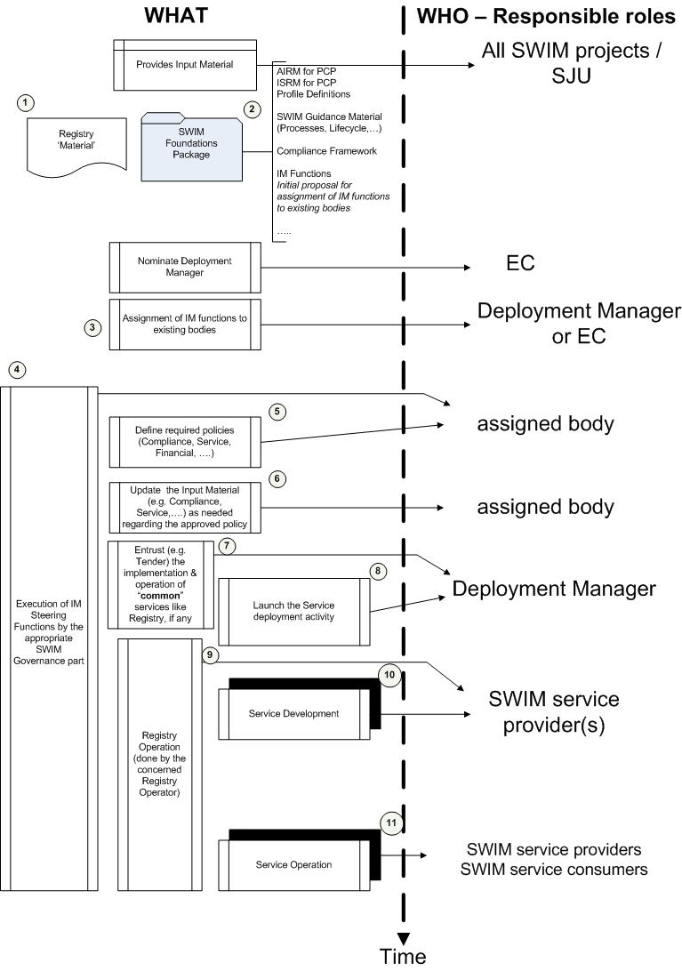
Figure 9 – Proposal for a high level roadmap for the PCP iSWIM deployment

The following text provides further details of the different steps shown in the roadmap.

① It is meant by ‘Registry Material’ all the ‘material’ that has been developed during the SESAR programme in the context of 8.3.2 project: model of the registry information, configuration of the registry, content of the registry (exported using an standard function of the registry product used in the project), deliverables of the project, etc. This material is provided “AS IS”.

The operational registry(ies) that will be implemented and operated (in ⑨) may be based on the same COTS and configuration than the one operated under SESAR or it may be different, so it is not known the level of reusability of this material.

② The name might be somewhat misleading as “SWIM Foundation” is also being used in 8.1 in the context of Data Modelling. Its scope here is larger, also covering all the ‘governance’ part (CONOPS, Compliance, IM Functions), the service part (8.3) and the SWIM-TI part (WP14 material). This corresponds to a list of material that has been developed during SESAR. It is expected (but to be confirmed) that the AIRM and ISRM will contain all information required for the PCP.

③ In this step, it is expected that the SESAR Deployment Manager establishes a SWIM Governance structure and allocates IM Functions to the appropriate bodies in such structure. Nevertheless, considering the information available about the composition of the Deployment Manager and the existing different views among the ANSPs on the SWIM Governance structure, it is assumed that the Deployment Manager will not set up any new / specific structure for the SWIM governance, but it will assign the IM functions to existing bodies.

④ Once the SWIM Governance structure is put in place, the assigned body(ies) should start taking care of the IM Steering Functions (Overall Governance, SWIM Evolution, Implementation Coordination and Global coordination). It can be expected that at that time, ‘real’ activity will be required mainly the Overall Governance and the SWIM Evolution management IM functions, the two others will very likely be in a ‘low intensity’ mode at that time.

⑤ The concerned assigned body should define the required policies. The definition of these policies will reflect the agreements among the concerned stakeholders about the level of ‘management and control’ of SWIM (to make an analogy, this can be compared to the Apple AppStore model – tight management over what is present in it-, or to the Android Market –medium management over what is present in it -, or to internet –basically no management of what is present-). As it is assumed that the implementation of SWIM services in the context of the PCP will be funded up to a given extent, a Financial Policy will certainly be required (although such policy will very likely have been set up to a large extent by the EC itself), so a certain level of ‘management and control’ will be required too.

⑥ The Input Material from step ② that was developed in the context of the SESAR programme may not be fully appropriate in the PCP deployment context as reflected in the defined policies. Therefore, it may be needed to update a number of “foundation” material received in step ② to adapt it to the approved policies. The material that has higher chances to require updates is the one regarding the SWIM Service Lifecycle and the Compliance Framework.

⑦, ⑨ The SWIM Registry is one of the key elements for the SWIM implementation and it is an essential tool to allow the management of SWIM. The definition of the SWIM Registry policy in step ⑤ (as part of the Service Policy) will define the agreement among stakeholders of the Registry architecture to be implemented (central, central plus distributed, fully distributed). In case it was agreed that a central (or common) part is required, the concerned SWIM governance part should perform the necessary actions to have this central part implemented and operated in the way defined in the policy (e.g., by a Tender action, by entrusting it to a given ‘entity’, other). The SWIM Registry shall be available, if possible, before any service implementation starts; or without a significant delay after the service provider start implementing services. This is so because the Registry should keep trace of the status of the services being implemented. The SWIM Registry, once put into operation, should be kept operating for as long as SWIM continues to operate.

The same consideration stated for the Registry can be also applied to other ‘common’ services that might have been agreed in the corresponding policies (like e.g. the implementation and operation of a PKI or a bridge-CA)

⑧, ⑩ Once the policies are defined and the Registry is in place (or planned to be in place in a short term future), the activities for the implementation and deployment of the services being part of the PCP can be launched. As such implementation and deployment is going to be funded (please check the Assumption note after the figure for other services that will not be funded), such services will have to apply the process and procedures identified in the corresponding policies.
Note: The previous high-level roadmap specifically avoids proposing a planning for the development and deployment of the different services which are part of the PCP iSWIM. Therefore, the steps ⑧, ⑩ and ⑪ can be running either in parallel or at different times for each concerned service.

  - Proposal of IM Functions ‘tailored’ for PCP/iSWIM

    - Definitions of designated and federated team

The project has defined 2 terms for the teams which are proposed to perform the functions:

- Designated team: a team set under the control of a central and single authority
- Federated (team): (team) united under a central governance
Hereafter follows a clarification of the meaning of these terms in the context of this document.
An organizational structure (in our case a « team ») is the outline of a framework for managing operations and processes. Two types of organizational structures (teams) are found in the business environment: centralized and decentralized.

Under the centralized concept, the term designated means that the organizational structure is set by the steering management to work on its behalf with a given mandate and timeframe. Individuals proposed to be part of the team work (full time) for this structure and do not represent anymore their own initial company. In other words, the individuals / representatives from stakeholders selected by the steering management to be part of the team constitute a group that makes decision and provides direction in the domain they have been mandated for.

Under the decentralized concept, the term federated team means that the organizational structure is made of a number of individuals / representatives from stakeholders that will dedicate part of their own work to the task set by the steering management. In other words, individuals / representatives from stakeholders selected by the steering management to be part of the team constitute a group of individuals from various companies which collectively proposes decision and provide direction in the domain they have been mandated for.

Advantages
A designated team can be extremely efficient regarding decision-making. It has a clear and consistent view of its mission and of the objectives and underlying vision of its subject.
A federated team utilize individuals with a variety of expertise and knowledge for working on various topics. A broad-based team helps to handle various types of contexts and situations and can ensure quicker buy-in.

Disadvantages
A designated team has the risk of losing the global perspective in the long term.

A federated team can struggle with multiple individuals having different opinions on a particular decision. As such, it can face difficulties trying to get everyone on the same page when proposing decisions.

The type of organization has a budget impact that varies with the extent of the work to be carried out. For punctual / temporary tasks, a federated team will be more cost efficient than a designated team since only the punctual / temporary corresponding actions will need to be funded (while a designated team needs a full-time funding anyway). When the extent of the work grows towards full-time activity, the operating costs of a federated team will grow as well and at some point become higher than the ones of a designated team.

    - List of IM Functions ‘tailored’ for PCP/iSWIM

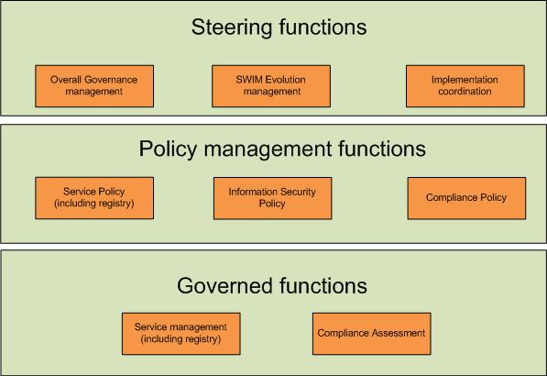
Figure 10 – List of IM Functions ‘tailored’ for PCP/iSWIM

The following table lists the proposed functions for PCP/iSWIM, including a proposed body for carrying out the function. This is not linked to any SWIM Governance proposal, but a pragmatic approach to support PCP/iSWIM deployment.

Functions | Proposed body
Steering functions
Overall Governance | Assigned body by the Deployment Manager (federated team).
SWIM Evolution Management | It starts for iSWIM with a ‘federated team’ assigned by the Deployment Manager, which includes representatives from affected stakeholders (including service providers and consumers). This initial approach may have to evolve as SWIM evolves and it might lead to having a ‘designated team’ allocated to this function.
Implementation coordination | This function is done by the service provider. (see note blue profile)
Policy Management Functions
Information Security Policy | The function is needed for the creation of the policy. A ‘federated team’ will write the policy definition, however policies are not considered to change very often after first implementation.
Service Policy | The function is needed for the creation of the policy.A ‘federated team’ will write the policy definition, however policies are not considered to change very often after first implementation.
Compliance Policy | A ‘federated team’ will write the policy definition, however policies are not considered to change very often after first implementation.
Governed functions
Compliance Assessment | The compliance assessment function will be done through a self-assessment by service providers.  Yet, other methods of (independent) assessments could be applied on a voluntary basis
Service Management | The functions will be done by the service providers and the registry service provider(s).

    - List of IM Functions not required for PCP/iSWIM

The following table lists the IM functions that are considered not required for PCP/iSWIM, including an explanation why the function is not required.

Functions | Why is the function not needed?
Steering functions
Global Coordination | The proposal considers that this IM Function is addressed by ad-hoc / current arrangements e.g. ICAO consultation arrangements, EUROCONTROL/FAA co-ordination group, EUROCONTROL AAB and sub-structure (Global Coordination is not specific to SWIM). The current working arrangements will need to be updated following the evolving requirements for coordination.  Considered the existing arrangements, it is not needed for the PCP / iSWIM deployment.
Policy Management Functions
Financial Policy | The proposal considers that the only Financial Policy available will be the one set by the European Commission in its regulations for the funding of the SESAR Deployment. It is assumed that the funding arrangements of the PCP/iSWIM cover the financial aspects for the iSWIM deployment and no specific financial policy for SWIM is needed. It is assumed that the operational running of the iSWIM services after the initial deployment is covered by the service provider.
Supervision Policy | The proposal considers that there will be no need in the context of the PCP to have Supervision implemented at a level higher than the local one. Therefore, no Supervision Policy will be needed, so this IM Function will not be needed.
Legal Aspects Policy | The proposal considers that no additional specific arrangements will be necessary for the PCP / iSWIM in addition to the existing national and European arrangements. Therefore, this IM Function will not be needed.
Governed functions
Financial Management | It is assumed that a Financial Policy will be available as defined by the EC for the SESAR Deployment. No specific for iSWIM Financial Policy will be required. Therefore, this proposal considers that this IM Function is not needed.
Information Security Management | The proposal assumes that even if a security policy is put in place, it will not impose to the service providers additional requirements specific to SWIM, other than what they are already supporting / implementing. Therefore, it is assumed that this IM function will not be needed
Supervision | The proposal assumes that there will no requirements on Supervision at level higher than the local one. Therefore, such IM Function will not be needed (see footnotes in section 3.3.4)

  - Details of IM Functions ‘tailored’ for PCP/iSWIM

The following sections provide further details concerning the scope, assumptions, remarks, etc. regarding the tailoring of the IM Functions for the PCP / iSWIM. Only the IM Functions that are considered as needed (fully or partially) are listed.

To facilitate the reading, the Description of the IM Function provided in the Section 3 is copied (and highlighted to make easier its distinction).

    - Steering Functions
In case the function is different dependant on the service that is provided (on Blue Profile, on Yellow Profile), it will be explicitly noted.
      - Overall Governance Management

Description.
This is a transversal function affecting all other IM Functions. It is the root of all IM functions, it defines who (entity, group) is responsible to execute the other IM functions if not already defined in an agreed SWIM Governance structure. Its purpose is to ensure that SWIM Governance is fulfilled properly, i.e. it does what it is supposed to be doing, detects shortcomings and defines corrective actions that need to be implemented. It also steers SWIM Governance overall to adapt to changing conditions.
The function acts on audit results and reports that are required by the different policies, and checks whether set performance goals are achieved, based on SWIM principles that have to be respected.
This function endorses the policies that are defined and updated by the policy functions.
The function handles the last escalation level in case of compliance disputes.
This function steers and provides direction in terms of:
- SWIM objectives,
- SWIM deployment strategy,
- Evolution and changes to the IM functions,
- Budget and decisions involving large expenditures.

Tailored proposal for the PCP/iSWIM.

It is recognised that the overall management function will be required and is mandatory for iSWIM deployment as overarching governing function over all the other implemented IM functions.
During the SESAR phase, this function is done by the SJU. In line with the current practices, the function should be performed by a federated team assigned by the Deployment Manager (potentially the AIM/SWIM Team or a subgroup depending from it).

      - SWIM Evolution Management
Description.
This function will provide the overall control board for SWIM standards and ‘SWIM common components’. It evaluates, approves or rejects change request. It ensures that decisions on change requests, submitted by e.g. the Global Co-ordination or the Service Lifecycle Management, are based on the best available expertise and supported by appropriate rationale.

This function covers several aspects:
- Evaluate proposals for and make decisions on updates/upgrades of ‘SWIM Common Infrastructure Services’ (e.g. SWIM Registry).
- Evaluate proposals for and make decisions on the definition and evolution of SWIM standards (e.g. SWIM TI, AIRM, ISRM,…).
- Apply approved change request to SWIM standards (e.g. maintenance of the AIRM and ISRM models, SWIM TI, etc.) and ensure proper maintenance of those standards.

Tailored proposal for the PCP/iSWIM.

This function will be needed because it is assumed that technical standards supporting SWIM will be subject to evolution within the iSWIM scope (e.g. there can be bugs in technical standards, new requirements for information or services, etc.). The Evolution management addresses: AIRM, ISRM, registry, SWIM TI definition (profiles, security, etc.).

The evolution of actual exchange models requires global management. This function may identify exchange model evolution requirements that will have to be brought forward to the global community through the Global Coordination IM function. The Global Coordination IM function may also feed this function with exchange model evolutions.

      - Implementation Co-ordination

Description.
This function will perform impact analyses of change requests that can impact the current operations requiring overall co-ordination for their implementation (e.g. putting in operation a new service instance, changes to operational service instance(s), changes to the SWIM infrastructure). The function will define appropriate transition plans and co-ordinate the execution of such plans.
This function will also ensure that maintenance plans are harmonised and co-ordinated and that they contain adequate provisions to minimise operational disruptions.

Tailored proposal for the PCP/iSWIM.

It is assumed that the service provider(s) will directly co-ordinate with its service consumers. For services implemented on the blue profile a co-ordination will be required, although we expect that this will be done by the service providers.
    - Policy Management Functions

      - Information Security Policy

Description.
The function provides (defines and updates) the information security policy applicable to SWIM. The information security policy provisions shall be proportional to security requirements.
A policy is required to cover the SWIM needs (in terms of Confidentiality, Integrity, Availability, etc.), the way the security policy is applied (e.g. enforcement by an ‘independent’ organization, on a voluntary basis, etc.), the audits that are needed and the way they are performed (e.g. by external ‘independent’ auditors, internally, etc.), the common security-relevant services accepted by stakeholders, etc.
The security policy:
- shall identify the roles and responsibilities in their application.
- may be limited to provisions already referenced in existing regulations and thus not require additional provisions by service providers or the implementation of SWIM Common Components.
- may additionally define a Security Framework including a stringent security policy based on a set of criteria (service consumer, requested service, unclassified/confidential/military/.. data, etc.) and eventually SWIM Common security Components. This Framework may include, inter-alia:
  - High level principles to be respected like equal right of access for all stakeholders, compliance with EU privacy protection rules.
  - A Security Risk Assessment Method to be applied.
  - Procedures to be established for user authentication.
  - Authorization criteria and process, including escalation procedures in case of disagreements.
  - Authorities accredited to check authentication of individuals.
  - Confidentiality and independence requirements through the authentication and authorization processes.
  - Other controls to be applied for the Confidentiality, Integrity, Availability and other security needs.
  - Roles and responsibilities, clarifying the relationship between security management oversight and runtime security.
  - What sort of security audits, if any, should be performed on services, infrastructure, service providers, SWIM Common Components, etc., as well as the responsibilities for such audits
- may address security exceptions to be granted e.g. linked to national limitations.
- may be made specific for different types of service depending on e.g. different operational safety requirements.

Tailored proposal for the PCP/iSWIM.

As policies are not considered to change very often after first implementation, this function will be mainly needed just for the creation of the policy.

For the Blue profile, it is recognised that a security policy is needed. Although due to the technical configuration and requirements of the Blue profile, it is assumed to be taken into account by the underlying network (private VPN network) and/or technical profile requirements. This is also assuming that the traffic is only between ANSPs (ATCs)..

For the yellow profile, a security policy is also needed, although this can be as simple as: “The providers need to align their security mechanisms between each other and with their customers”.

It has to be considered that the Information Security policy may need to be approved at each NSA.

      - Service Policy (including Registry)

Description.

This function manages (defines and updates) the Service Lifecycle policy, including the Registry policy. The service lifecycle comprises several steps that a service needs to traverse from its inception to its deprecation (see also chapter 3.3.5).

It defines all artefacts required to be produced during a service’s lifecycle and provides appropriate guidelines and rules to be applied (e.g. foundation material, templates).

The service policy may be specific for the different services types (e.g. non-safety critical, safety critical, etc.).

It is not in the scope of transversal SWIM governance to stipulate how a provider manages his service lifecycle process (SLMP) as long as the level of quality of the artefacts he produces is compliant with the intended compliance level. The Service Lifecycle policy will stipulate the specific milestones and the associated artefacts that mostly also constitute a gate in the transition from one major lifecycle step to another (see Figure 2). It is therefore suggested to utilize a lean SLMP that shows the outcomes of the main steps of the SLMP.

Figure 11 – SLMP

As the SWIM Registry is considered as a service provision (although a special case, i.e. a SWIM Common Component), the policy management regarding the Registry is considered to be part of this IM Function. Nevertheless, the Registry service has some specifics that will not be covered by ATM service lifecycle policy.

Therefore, this IM function will define for the Registry Policy, inter alia:

- the split between a central and local registries
- the interaction, if required, between the various registries,
- the details on the recognition of registration between various registries
- the entity(ies) running and controlling the registry(ies)
- the quality of service of the registry operation
- the security aspects, including confidentiality to be taken into account by the service manager function, the criteria for the assignment of access rights to SWIM stakeholders (providers, consumers, infrastructure providers), the cases leading to revoked access, data protection, etc.
- the procedure leading to removal of services from the registry
- the registry metadata about services
- the service provider taxonomy

Tailored proposal for the PCP/iSWIM.

The PCP is the trigger to start the SWIM governance process; it sets the basis for new services but also for the change of the PCP / iSWIM services. As the registry has been included as a service in this IM Function, a policy for running the registry (maintenance, content updates needs to be also defined (this would be applicable for other potential "common" services).

A policy is needed because it cannot be expected that the services will be stable during the entire PCP timescope (e.g. definitions).

It is assumed that:
- It is assumed that the policy will not change during the PCP lifetime, therefore, this function will be mainly needed just for the creation of the policy.
- The Service Policy for the PCP will be lighter than the current SESAR process (B4.3 T5 process).

The defined Service Policy will be applicable to all services defined as part of the PCP / iSWIM.

Concerning the registry, the policy should cover both central and local registries. The policy should define the level of interoperability between registries (as applicable).

      - Compliance Policy
Description.
The function manages (defines and updates) the SWIM Compliance Principles and Criteria (on the basis of existing SWIM Compliance Principles and Criteria documents). This Compliance policy may cover items (objects under assessment) such as service definitions; service Instances, SWIM infrastructure (e.g. SWIM nodes) etc.

It defines:

- How compliance is assessed (e.g. self-assessment, assessment by an independent testing institute, use of a Common Service for compliance assessment) and its relationship with existing regulation bodies (e.g. NSA, EASA) as appropriate.
- High level principles to be respected like e.g.:
  - ensure that, in the case of service provision, the data / information provided is fit for purpose and fulfils the applicable regulations (e.g. personnel qualification, quality management)
  - Ensure there will be no impact on operational systems during the compliance assessment.
- Means of compliance
- The escalation process (the last escalation level will be referred to the Overall Governance management function).
The compliance policy shall be adapted to various configurations:
- The compliance policy (criteria and compliance assessment) may be different for the different types of objects under assessment covered (e.g. a service definition or a service instance)
- The compliance policy (criteria and compliance assessment) may be different for the different types of services (e.g. non-safety critical, safety critical, etc).
- The compliance policy (criteria and compliance assessment) may be different for different stakeholder groups (e.g. States, ANSPs, private sector companies)

The compliance policy shall include the compliance arrangements with other SWIM implementations (co-ordinated through the Global co-ordination function).

Tailored proposal for the PCP/iSWIM.

Compliance to SWIM standards is a pre-requisite for the interoperability. Compliance is also a means (not necessarily the only one) to assess the appropriateness SWIM standards. E.g.: compliance may well show that a given standard has been set much too high and needs to be reconsidered.

It is assumed that the policy will not change during the PCP lifetime; therefore, this function will be mainly needed just for the creation of the policy.

This policy shall identify the type of assessment and the means of compliance required for the iSWIM deployment (PCP context).

The policy will be different depending on the concerned profile. The usage of the blue profile is expected to require higher compliance levels. Therefore, it can be more critical for services using the blue profile since it may require high level of trust in the robustness of the services.

    - Governed Functions

      - Compliance Assessment

Description.
This function assigns the performance of compliance assessments as defined by the Compliance Policy Management function to service providers. These compliance assessments may mean executing tests available from third parties and furnishing such test reports as proof of compliance. They may alternatively mean that a formalized certification process needs to be undertaken by the service provider.
This function performs the compliance assessment actions, if such actions are defined in the Compliance Policy document.

- As a minimum, this function is supposed to cover the reception and analysis of compliance assessment reports before awarding the corresponding compliance level and entering this information in the Registry.
- Eventually, this function could also cover a much broader scope: from performing the actual assessment (i.e. executing a number of predefined tests/audits) to the implementation and maintenance of appropriate test suites for different service definitions.

Tailored proposal for the PCP/iSWIM.

Compliance to SWIM standards is a pre-requisite for the interoperability.

It is assumed that:
- Clear criteria have been defined, clear process has been established.
- Compliance means will range from very simple to very stringent.
- Criteria for the infrastructure compliance assessment has been developed and it is available (not the case yet).

This IM Function will be applicable to all service providers for all the iSWIM services they provide and it will be also applicable to the SWIM infrastructure.
There are a number of topics that will have to be clarified:
- What about test infrastructure?
- Will supporting tools for the conduction of assessments be provided?
- "Self-assessment" needs to be clearly defined (e.g. is interoperability testing with external partners part of it or not?)

      - Service Management (including Registry)

Description.
In the scope of this function the activities in conjunction with the Service Lifecycle Policy as well as the Compliance Policy concerning the infrastructure and services provided by service providers are performed. For example in case a service provider would like to implement a new service instance, the aforementioned policies will indicate what actions and artefacts need to be performed/created to put the new service in operation at any given compliance level.

This function shall define the implementing / transition plan to put a service into operations. It shall also define provisions addressing the potential interdependencies with other services.
This service management for the registry could cover, inter-alia, the following aspects:
- Maintaining all information related to services in the Registry including Service Definitions and Service Instances. Depending on the type (Service Definition vs. Instance) different attributes (to be defined in the Service Lifecycle Policy) will have to be maintained.
- Maintenance of other information stored in the Registry related to e.g.
  - The list of SWIM standards
  - Reference documents
  - SWIM participants (consumers and providers): handling of registration requests, definitions in the registry, allocation of appropriate access rights, etc.
- Other administration tasks concerning the information stored in the Registry. Such tasks could be cleaning up, triggering appropriate actions at the appropriate time (e.g. when the validation period of a compliance allocation expires, etc.).
- Technical maintenance of the registry infrastructure such as the implementation of upgrades or changes mandated by the SWIM Evolution Management function.

Tailored proposal for the PCP/iSWIM.

This IM function is needed as it ensures a common approach to service development across SWIM stakeholders and helps to reach a defined level of quality. It is also a required basis for compliance assessment, and it also provides a global picture of services being developed (via the Registry).
The scope of this IM Function should be applicable to all services within the PCP / iSWIM deployment context. Concerning the registry, the scope should cover all implemented registry(ies) and their content(s).
- Engineering Artefacts

This appendix provides the content of section 3 IM Function Descriptions in the form of Engineering Artefacts.
The requirements listed hereafter are address the enabler “SWIM-GOV-05a” and OI Step IS-0901-A.
  - Steering Functions

    - Overall Governance Management

Identifier | REQ-08.01.01-CONOPS-OGMa.0010
Requirement | The SWIM Governance Authority shall establish an IM Function responsible for the Overall Governance Management.

Identifier | REQ-08.01.01-CONOPS-OGMa.0015
Requirement | The Overall Governance Management IM function shall define the roles and responsibilities of all SWIM governance bodies and ensure transparency on the decision making process

Identifier | REQ-08.01.01-CONOPS-OGMa.0020
Requirement | The Overall Governance Management IM function shall steer SWIM Governance overall to adapt to changing conditions.

Identifier | REQ-08.01.01-CONOPS-OGMa.0025
Requirement | The Overall Governance Management IM function shall set and supervise the strategy, policy, principles and common procedures for the SWIM Governance.

Identifier | REQ-08.01.01-CONOPS-OGMa.0027
Requirement | The Overall Governance Management IM function shall identify and establish the relevant decision bodies to perform change management on the various elements that build the SWIM Foundation, standards & guidelines.

Identifier | REQ-08.01.01-CONOPS-OGMa.0030
Requirement | The Overall Governance Management IM function shall act on audit results and reports that are required by the different policies, and shall check whether set performance goals are achieved, based on SWIM principles that have to be respected.

Identifier | REQ-08.01.01-CONOPS-OGMa.0040
Requirement | The Overall Governance Management IM function shall endorse the policies that are defined and updated by the policy functions and provide policy guidance.

Identifier | REQ-08.01.01-CONOPS-OGMa.0050
Requirement | The Overall Governance Management IM function shall handle the last escalation level in case of compliance disputes.

Identifier | REQ-08.01.01-CONOPS-OGMa.0060
Requirement | The Overall Governance Management IM function shall steer and provide direction in terms of: SWIM objectives, SWIM deployment strategy, evolution and changes to the IM functions, budget and decisions involving large expenditures.

    - Global Co-ordination

Identifier | REQ-08.01.01-CONOPS-GloC.0010
Requirement | The SWIM Governance Authority shall establish an IM Function responsible for the Global Co-ordination.

Identifier | REQ-08.01.01-CONOPS-GloC.0020
Requirement | The Global Co-ordination IM function shall be responsible to ensure global consistency and compliance with all applicable rules and regulations.

Identifier | REQ-08.01.01-CONOPS-GloC.0030
Requirement | The Global Co-ordination IM function shall be responsible for the global coordination and standardisation in support of SWIM

Identifier | REQ-08.01.01-CONOPS-GloC.0040
Requirement | The Global Co-ordination IM function shall be responsible for liaising with:  - international standards bodies (ISO, OGC, ESOs, EUROCAE, etc.)  - regulatory bodies, e.g. ICAO, EU, EASA, FAA.

Identifier | REQ-08.01.01-CONOPS-GloC.0050
Requirement | The Global Co-ordination IM function shall be responsible for co-ordinating at global level how the mutual recognition of compliance (criteria, means of compliance) will be handled between different SWIM implementations.

Identifier | REQ-08.01.01-CONOPS-GloC.0060
Requirement | The Global Co-ordination IM function shall be responsible, concerning the SWIM Standards and the SWIM Foundation for:  - providing input from European and international committees and standardisation organisations in the case of a relation to SWIM.  - coordinating with appropriate European standardisation organisations

    - SWIM Evolution Management

Identifier | REQ-08.01.01-CONOPS-SWEM.0010
Requirement | The SWIM Governance Authority shall establish an IM Function responsible for the SWIM evolution management.  The SWIM Evolution Management IM Function shall control evolution of SWIM standards and requirements on ‘SWIM common components’ to ensure coherency and consistency across all of that.

Identifier | REQ-08.01.01-CONOPS-SWEM.0020
Requirement | The SWIM Evolution Management IM Function shall be responsible for providing the overall control board for SWIM standards and ‘SWIM Common Infrastructure Services.

Identifier | REQ-08.01.01-CONOPS-SWEM.0030
Requirement | The SWIM Evolution Management IM Function shall be responsible for evaluating proposals, approving or rejecting change request to SWIM elements. The SWIM elements are the SWIM Foundation, SWIM Guidance Material and SWIM Standards (e.g. SWIM middleware, AIRM, ISRM).

Identifier | REQ-08.01.01-CONOPS-SWEM.0050
Requirement | The SWIM Evolution Management IM Function shall be responsible for applying approved change request to SWIM standards (e.g. maintenance of the AIRM and ISRM models, SWIM architecture description, etc) and ensuring proper maintenance of those standards.

Identifier | REQ-08.01.01-CONOPS-SWEM.0060
Requirement | The SWIM Evolution Management IM Function shall be responsible for ensuring the provisioning and maintenance of governance related artefacts like compliance criteria, templates, etc.

Identifier | REQ-08.01.01-CONOPS-SWEM.0070
Requirement | The SWIM Evolution Management IM Function shall be responsible for ensuring the SWIM Change Management, whether the Change Control Board is established as an internal part of the SWIM Governance structure (e.g. ISRM CCB) or if there is a need to coordinate with external CCBs.

Identifier | REQ-08.01.01-CONOPS-SWEM.0080
Requirement | The SWIM Evolution Management IM Function shall be responsible, regarding the ‘strategic’ SWIM Change Management, for:  - Establishing change control boards.  - Providing overall directions to the CCBs.  - Setting the priorities for the development of the SWIM Foundation, SWIM Registry and SWIM TI.  - Provide and maintain a SWIM Foundation Evolution Plan and SWIM Standards Evolution Plan.  - Ensuring a consistent evolution and changes to the SWIM Foundation Landscape, including the SWIM Foundation, the SWIM Standards and the SWIM Guidance Material,

Identifier | REQ-08.01.01-CONOPS-SWEM.0090
Requirement | The SWIM Evolution Management IM Function shall be responsible, regarding the ‘operative’ SWIM Change Management, for:  - Evaluate change requests and allocate to the appropriate internal or external CCB or CCBs.  - Manage the evolution of the SWIM Policies and SWIM Standards.  - Maintain the SWIM Governance Framework.  For "internal" CCBs  - Run the CCBs  - coordinate Communicate between CCBs and act as the escalation body in case of disagreements  - Analyse Change requests and technical change proposals from SWIM users and provide recommendations to the relevant CCBs.  - Review and approve the ToRs and procedures of the CCBs  - Make decisions on updates/upgrades of 'SWIM Common Infrastructure Components' (e.g. SWIM Registry) and of SWIM standards (e.g. AIRM, ISRM).  - Working on Change Request and provide technical solutions.  For "External" CCBs  - Elaborate appropriate Change Requests  - Organize the contributions either through liaison with the European participants, or through direct contribution.  - Gather inputs from the CCBs meetings, analyse any decisions and evolutions affecting the European SWIM deployment.

    - Implementation Co-ordination

Identifier | REQ-08.01.01-CONOPS-ImCo.0010
Requirement | The SWIM Governance Authority shall establish an IM Function responsible for the Implementation Co-ordination.

Identifier | REQ-08.01.01-CONOPS-ImCo.0020
Requirement | The Implementation Co-ordination IM Function shall be responsible for performing impact analyses of change requests if it is anticipated, that there will be a great influence on the current operations which requires an overall co-ordination for their implementation). More precisely, this function shall:  - decide on the need for over-all coordination and coordinate from the approval of a change request until the final implementation,  - analyse and approve integration plans, integration documentation and test reports,  - perform impact analyses concerning the consequences of approved change requests,  - manage the implementation of the SWIM policies and standards,  - conduct impact analysis of Change Requests related to planning and project management matters, notably identifying planning dependencies,

Identifier | REQ-08.01.01-CONOPS-ImCo.0030
Requirement | The Implementation Co-ordination IM Function shall be responsible for defining the appropriate transition plans and co-ordinating the execution of such plans when needed.

Identifier | REQ-08.01.01-CONOPS-ImCo.0040
Requirement | The Implementation Co-ordination IM Function shall be responsible for ensuring that maintenance plans are harmonised and co-ordinated and that they contain adequate provisions to minimise operational disruptions.

Identifier | REQ-08.01.01-CONOPS-ImCo.0050
Requirement | The Implementation Co-ordination IM Function shall be responsible for providing support in the execution of compliance assessments.  - analyse compliance reports and identify recommended actions,  - provide directives and support to accomplish compliance assessments,  - coordinate between the SWIM providers and the mandated assessor, when applicable as defined by the compliance policy,  - mandate assessors to perform compliance assessments, when applicable as defined by the compliance policy,

Identifier | REQ-08.01.01-CONOPS-ImCo.0060
Requirement | The Implementation Co-ordination IM Function shall be responsible for undertaking the SWIM Problem Management:  - determine technical solutions to SWIM user problem reports,  - process and escalate problem reports,  and it shall also provide a mediator role between SWIM Users if conflicts arise between them.

Identifier | REQ-08.01.01-CONOPS-ImCo.0070
Requirement | The Implementation Co-ordination IM Function shall be responsible for undertaking the SWIM Contract Management:  - produce and manage contracts and ensure that the expected service quality is met,  - monitor the SWIM service management between providers and consumers, i.e. monitor version change, deprecation, cutover dates etc.,  - maintain a record of the SWIM modification activities,

  - Policy Management Functions

    - Financial Policy

Identifier | REQ-08.01.01-CONOPS-FiPo.0010
Requirement | The SWIM Governance Authority shall establish an IM Function responsible for the SWIM Financial Policy.

Identifier | REQ-08.01.01-CONOPS-FiPo.0020
Requirement | The Financial Policy IM Function shall be responsible for managing (defining and updating) the SWIM financial policy related to funding and charging in terms of:  - SWIM Governance structure  - Provision and operation of SWIM Common Components and Services  - Compliance assessment activities  - Potentially the provision, upgrades and operation of infrastructure and services by service providers.  - Potentially required auditing activities  - etc

    - Information Security Policy

Identifier | REQ-08.01.01-CONOPS-ISPo.0010
Requirement | The SWIM Governance Authority shall establish an IM Function responsible for the SWIM Information Security Policy.

Identifier | REQ-08.01.01-CONOPS-ISPo.0020
Requirement | The Information Security Policy IM Function shall be responsible for managing (defining and updating) the information security policy applicable to SWIM.

Identifier | REQ-08.01.01-CONOPS-ISPo.0030
Requirement | The information security policy provisions shall be proportional to security requirements.

Identifier | REQ-08.01.01-CONOPS-ISPo.0040
Requirement | The Information Security Policy IM Function shall identify the roles and responsibilities in their application.

Identifier | REQ-08.01.01-CONOPS-ISPo.0050
Requirement | The Information Security Policy IM Function shall consider whether the security policy may be limited to provisions already referenced in existing regulations and thus not require additional provisions by service providers or the implementation of SWIM Common Components.

Identifier | REQ-08.01.01-CONOPS-ISPo.0060
Requirement | The Information Security Policy IM Function shall define, if justified, a Security Framework including a stringent security policy (authentication, authorisation, encryption, …) based on a set of criteria (service consumer, requested service, unclassified/confidential/military/.. data, etc.) and eventually SWIM Common security Components..

Identifier | REQ-08.01.01-CONOPS-ISPo.0070
Requirement | The Information Security Policy IM Function shall address security exceptions to be granted e.g. linked to national limitations..

Identifier | REQ-08.01.01-CONOPS-ISPo.0080
Requirement | The Information Security Policy IM Function shall allow the security policy to be made specific for different types of service depending on e.g. different operational safety requirements.

    - Service Policy (including Registry)

Identifier | REQ-08.01.01-CONOPS-SePo.0010
Requirement | The SWIM Governance Authority shall establish an IM Function responsible for the SWIM Service Policy (including Registry).

Identifier | REQ-08.01.01-CONOPS-SePo.0020
Requirement | The Service Policy IM Function shall be responsible for managing (defining and updating) the SWIM Service Lifecycle policy.

Identifier | REQ-08.01.01-CONOPS-SePo.0030
Requirement | The Service Policy IM Function shall define all artefacts required to be produced during a service’s lifecycle and provides appropriate guidelines and rules to be applied (e.g. foundation material, templates).

Identifier | REQ-08.01.01-CONOPS-SePo.0040
Requirement | The Service Policy IM Function shall allow the service policy to be made specific for the different services types (e.g. non-safety critical, safety critical, etc).

Identifier | REQ-08.01.01-CONOPS-SePo.0050
Requirement | The Service Policy IM Function shall be responsible for managing (defining and updating) the SWIM Registry policy.

Identifier | REQ-08.01.01-CONOPS-SePo.0060
Requirement | The Registry policy defined by the Service Policy IM Function shall cover, inter-alia:  - the split between a central and local registries  - the interaction, if required, between the various registries,  - the details on the recognition of registration between various registries  - the entity(ies) running and controlling the registry(ies)  - the quality of service of the registry operation  - the security aspects, including confidentiality to be taken into account by the service manager function, the criteria for the assignment of access rights to SWIM stakeholders (providers, consumers, infrastructure providers), the cases leading to revoked access, data protection, etc.  - the procedure leading to removal of services from the registry  - the registry metadata about services  - the service provider taxonomy

    - Compliance Policy

Identifier | REQ-08.01.01-CONOPS-CoPo.0010
Requirement | The SWIM Governance Authority shall establish an IM Function responsible for the SWIM Compliance Policy.

Identifier | REQ-08.01.01-CONOPS-CoPo.0020
Requirement | The Compliance Policy IM Function shall be responsible for managing (defining and updating) the SWIM Compliance Principles and Criteria.

Identifier | REQ-08.01.01-CONOPS-CoPo.0030
Requirement | The Compliance Policy IM Function shall define the items covered (objects under assessment) such as service definitions; service Instances, SWIM infrastructure (e.g. SWIM nodes) etc.

Identifier | REQ-08.01.01-CONOPS-CoPo.0040
Requirement | The Compliance Policy IM Function shall define how compliance is assessed (e.g. self-assessment, assessment by an independent testing institute, use of a Common Service for compliance assessment) and its relationship with existing regulation bodies (e.g. NSA, EASA) as appropriate.

Identifier | REQ-08.01.01-CONOPS-CoPo.0050
Requirement | The Compliance Policy IM Function shall define the high level principles to be respected like e.g.:  - Ensure that, in the case of service provision, the data / information provided is fit for purpose and fulfils the applicable regulations (e.g. personnel qualification, quality management)  - Ensure there will be no impact on operational systems during the compliance assessment.

Identifier | REQ-08.01.01-CONOPS-CoPo.0060
Requirement | The Compliance Policy IM Function shall define the Compliance Criteria, i.e. what are the compliance artefacts to be produced for the SWIM Compliance assessment.

Identifier | REQ-08.01.01-CONOPS-CoPo.0070
Requirement | The Compliance Policy IM Function shall define the escalation process (the last escalation level will be referred to the Overall Governance management function).

Identifier | REQ-08.01.01-CONOPS-CoPo.0080
Requirement | The Compliance Policy IM Function shall define a compliance policy that shall be able to adapt to various configurations like:  - The compliance policy (criteria and compliance assessment) may be different for the different types of objects under assessment covered (e.g. a service definition or a service instance)  - The compliance policy (criteria and compliance assessment) may be different for the different types of services (e.g. non-safety critical, safety critical, etc.).  - The compliance policy (criteria and compliance assessment) may be different for different stakeholder groups (e.g. States, ANSPs, private sector companies)

Identifier | REQ-08.01.01-CONOPS-CoPo.0090
Requirement | The Compliance Policy IM Function shall include the compliance arrangements with other SWIM implementations (co-ordinated through the Global co-ordination function).

    - Supervision Policy

Identifier | REQ-08.01.01-CONOPS-SuPo.0010
Requirement | The SWIM Governance Authority shall establish an IM Function responsible for the SWIM Supervision Policy.

Identifier | REQ-08.01.01-CONOPS-SuPo.0020
Requirement | The Supervision Policy IM Function shall be responsible for managing (defining and updating) the SWIM Supervision Policy.

Identifier | REQ-08.01.01-CONOPS-SuPo.0030
Requirement | The Supervision Policy IM Function shall define a supervision policy which covers the need, if any, for SWIM Supervision (e.g. Configuration Management, Fault Management, Performance Management, etc.) at various levels, which may be local, FAB/sub-regional and/or the European level (e.g. through the use of a Common Service).

Identifier | REQ-08.01.01-CONOPS-SuPo.0040
Requirement | In case the supervision policy would cover the Performance Management, the supervision policy shall consider covering requirements on performance definition and monitoring, independence of the body that provides the performance monitoring (how is this ensured?, who is responsible to perform the monitoring?), distribution of monitoring results, provisions in case of no compliance with specified targets, etc.

    - Legal Aspects Policy

Identifier | REQ-08.01.01-CONOPS-LAPo.0010
Requirement | The SWIM Governance Authority shall establish an IM Function responsible for the SWIM Legal Aspects Policy.

Identifier | REQ-08.01.01-CONOPS-LAPo.0020
Requirement | The Legal Aspects Policy IM Function shall be responsible for managing (defining and updating) the SWIM Legal Aspects Policy.

Identifier | REQ-08.01.01-CONOPS-LAPo.0030
Requirement | The SWIM Legal Aspects Policy may cover the handling of copyrighted service interfaces in the case the corresponding services are deemed necessary on SWIM.

Identifier | REQ-08.01.01-CONOPS-LAPo.0040
Requirement | The SWIM Legal Aspects Policy may cover the definition of the SWIM participation policy and the associated formal registration procedures (for consumers, providers of services). The SWIM Legal Aspects Policy may have to define who (entity, group) is responsible to implement this participation policy if not already defined in an agreed SWIM Governance structure.

Identifier | REQ-08.01.01-CONOPS-LAPo.0050
Requirement | The SWIM Legal Aspects Policy may cover the ownership and liability policy in general, and more specifically:  - in case of re-use of information.  - Liability in case of accident or incident due to a SWIM component failure.

Identifier | REQ-08.01.01-CONOPS-LAPo.0060
Requirement | The SWIM Legal Aspects Policy may cover the Intellectual Property Rights policy, also including the definition of mechanism to co-ordinate and arbitrate IPR issues across borders and boundaries, taking due account of national legislations. This includes the licensing framework for the use of the AIRM and ISRM.

Identifier | REQ-08.01.01-CONOPS-LAPo.0070
Requirement | The SWIM Legal Aspects Policy may cover the limitations to the use of some data.

Identifier | REQ-08.01.01-CONOPS-LAPo.0080
Requirement | The SWIM Legal Aspects Policy may cover the definition of a legal framework for SWIM incident analysis / investigation, if any, taking into consideration cross-borders aspects. This framework may have to define roles and responsibilities. It may have to cover the follow up of investigation results and enforcement of remedial actions by the Overall Governance management function

Identifier | REQ-08.01.01-CONOPS-LAPo.0090
Requirement | The SWIM Legal Aspects Policy shall define the entity(ies) responsible to ‘enforce’ it and the way such ‘enforcement’ will be performed.

  - Governed Functions

    - Financial Management

Identifier | REQ-08.01.01-CONOPS-FiMa.0010
Requirement | The SWIM Governance Authority shall establish an IM Function responsible for the Financial Management.

Identifier | REQ-08.01.01-CONOPS-FiMa.0020
Requirement | The Financial Management IM Function shall be responsible for implementing the actions set out in the Financial Policy

    - Information Security Management

Identifier | REQ-08.01.01-CONOPS-ISMa.0010
Requirement | The SWIM Governance Authority shall establish an IM Function responsible for the Information Security Management.

Identifier | REQ-08.01.01-CONOPS-ISMa.0020
Requirement | The Information Security Management IM Function shall be responsible for implementing the actions set out in the Information Security Policy.

Identifier | REQ-08.01.01-CONOPS-ISMa.0030
Requirement | The Information Security Management IM Function shall be responsible for implementing and maintaining the common information security services specified in the Information Security Policy.

    - Supervision

Identifier | REQ-08.01.01-CONOPS-Spvr.0010
Requirement | The SWIM Governance Authority shall establish an IM Function responsible for the Supervision.

Identifier | REQ-08.01.01-CONOPS-Spvr.0020
Requirement | The Supervision IM Function shall be responsible for implementing the tasks defined in the Supervision Policy. The scope of this action could range from:  - Nothing to be done.  - Just producing a number of periodic reports and submitting them to a higher level of supervision  - Implementing specific supervisory task related services to provide supervision information to a higher level of supervision.  - Implementing specific supervision related services to allow control (the level of control should be defined) from a higher level of supervision.  - Providing a consolidated European level supervision as Common Service, in case the Supervision Policy indicated that there was a need for supervision at European level (even if it was just to consolidate reports received from the Local or sub-regional levels).

    - Compliance Assessment

Identifier | REQ-08.01.01-CONOPS-CpAs.0010
Requirement | The SWIM Governance Authority shall establish an IM Function responsible for the Compliance Assessments.

Identifier | REQ-08.01.01-CONOPS-CpAs.0020
Requirement | The Compliance Assessment IM Function shall perform the compliance assessment actions defined in the Compliance Policy.

Identifier | REQ-08.01.01-CONOPS-CpAs.0030
Requirement | The Compliance Assessment IM Function shall assign the performance of compliance assessments as defined by the Compliance Policy Management function to service providers.

    - Service Management (including Registry)

Identifier | REQ-08.01.01-CONOPS-SeMa.0010
Requirement | The SWIM Governance Authority shall establish an IM Function responsible for the Service Management, including the SWIM Registry.

Identifier | REQ-08.01.01-CONOPS-SeMa.0020
Requirement | The Service Management IM Function shall be responsible for performing the activities defined in the Service Policy.
 | For example in case a service provider would like to implement a new service instance, the aforementioned policy will indicate what actions and artefacts need to be performed/created to put the new service in operation at any given compliance level. The service management function will provide input to the compliance assessment function.

Identifier | REQ-08.01.01-CONOPS-SeMa.0022
Requirement | The Service Management IM Function shall be responsible for offering SWIM Information Services following the rules and guidelines provided by the SWIM Service Policy and further applicable documents.
 | For example in case a service provider would like to implement a new service instance, the aforementioned policies will indicate what actions and artefacts need to be performed/created to put the new service in operation at any given compliance level.

Identifier | REQ-08.01.01-CONOPS-SeMa.0024
Requirement | The Service Management IM Function shall be responsible for offering SWIM Common Infrastructure Components following the rules and guidelines provided by the SWIM Service Policy and further applicable documents.
 | For example in case a service provider would like to implement a new service instance, the aforementioned policies will indicate what actions and artefacts need to be performed/created to put the new service in operation at any given compliance level.

Identifier | REQ-08.01.01-CONOPS-SeMa.0026
Requirement | The Service Management IM Function shall be responsible for performing the service lifecycle in accordance to the SWIM Service policy, if needed defining an integration and transition plan to put a service into operations. It shall also define provisions addressing the potential interdependencies with other services.
 | For example in case a service provider would like to implement a new service instance, the aforementioned policies will indicate what actions and artefacts need to be performed/created to put the new service in operation at any given compliance level.

Identifier | REQ-08.01.01-CONOPS-SeMa.0030
Requirement | The Service Management IM Function, for the part related to the Registry, shall be responsible for maintaining all information related to services in the SWIM Registry including Service Definitions, when updates or new service definitions are required, and Service Instances. Depending on the type (Service Definition vs. Instance) different attributes (to be defined in the Service Lifecycle Policy) will have to be maintained.

Identifier | REQ-08.01.01-CONOPS-SeMa.0040
Requirement | The Service Management IM Function, for the part related to the SWIM Registry, shall be responsible for performing the maintenance of other information stored in the Registry related to e.g.:  - The list of SWIM standards  - Reference documents  - SWIM participants (consumers and providers): handling of registration requests, definitions in the registry, allocation of appropriate access rights, etc.

Identifier | REQ-08.01.01-CONOPS-SeMa.0050
Requirement | The Service Management IM Function, for the part related to the SWIM Registry, shall be responsible for performing other administration tasks concerning the information stored in the Registry as cleaning up, triggering appropriate actions at the appropriate time (e.g. when the validation period of a compliance allocation expires), etc.

Identifier | REQ-08.01.01-CONOPS-SeMa.0060
Requirement | The Service Management IM Function, for the part related to the SWIM Registry, shall be responsible for performing the technical maintenance of the registry infrastructure such as the implementation of upgrades or changes mandated by the SWIM Evolution Management function.

- Mapping IM Functions – Governance structure.
Although not being part of the purpose of this document, this Appendix presents a potential mapping between the IM Functions defined in it and a potential SWIM Governance structure.
The SWIM CONOPS document (ref. [1]) described two different Governance structures. One of them was produced by the A6 (still under discussion) and it is copied hereafter.
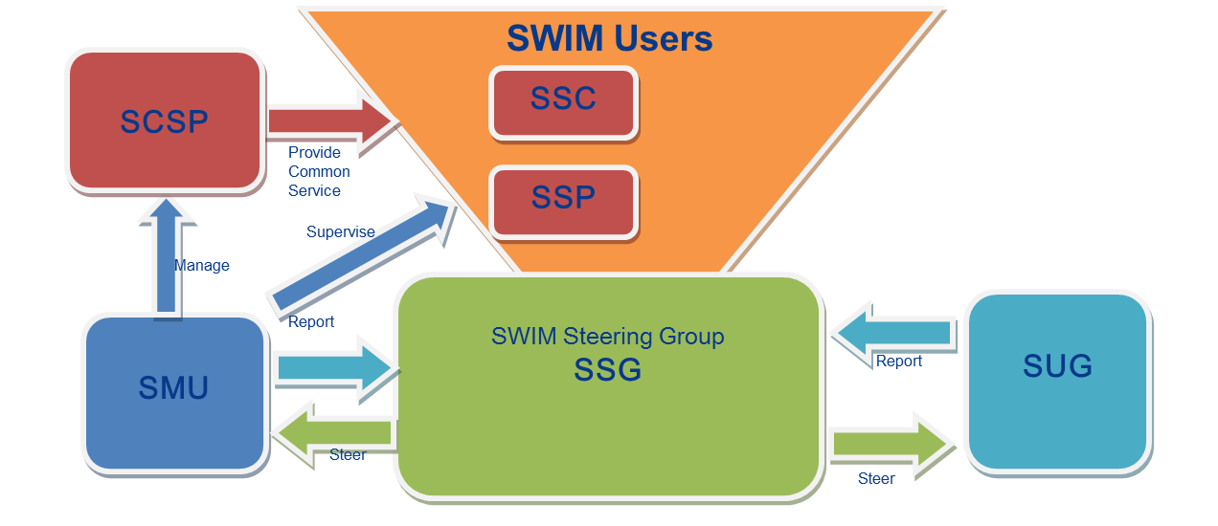
Figure 12 - A6's proposal for a SWIM Governance structure
The IM Functions would be mapped to such Governance structure as follows.

SSG | Overall Governance Management
SMU | Global Co-ordination
 | SWIM Evolution Management
 | Implementation Co-ordination
SEG | Financial Policy
 | Information Security Policy
 | Service Policy (including Registry)
 | Compliance Policy
 | Supervision Policy (optional)
 | Legal Aspects Policy
SSP/SCSP | Service Management
 | Financial Management
 | Compliance Assessment
 | Supervision (optional)
SSP/SSC | Information Security Management (optional)
- Draft proposal for a SWIM Compliance Policy as an input for the Deployment Manager

  - Assumptions
A first step in the clarification of the SESAR deployment has been achieved with the nomination of the Deployment Manager (DM) by the EC. Nevertheless, at the time this document is produced, the DM is at its earliest stages, so it is not clear yet the actual SWIM governance that is going to be setup. All or the main part of the following assumptions are actually due to this fact.
The policy provided hereafter has been produced with the following assumptions:
- There will be a SWIM Authority in charge of the SWIM governance. No further assumption is made on the ‘structure’ of this authority (e.g. bodies), even if the SESAR documents contain proposals for it.
- There will be a SWIM Registry where SWIM service instances, SWIM service definitions and all SESAR SWIM material applicable to the PCP will be available. No further assumption is made on who will be responsible / operate such SWIM Registry and how will be technically implemented.
- There will be a SWIM Registry policy. No further assumption is made on who will produce the Registry policy, but for what is related to the SWIM Compliance policy, it is assumed that:
  - The SWIM Registry will have at least two domains. One of them fully open and accessible without any authentication mechanism, the other restricted to authenticated users.
  - All general information related to SWIM (ConOps, Compliance Framework, AIRM, ISRM, SWIM Profiles, Service Description Document, Service Technical Design Document, templates etc) will be available in the open domain.
  - All detailed information related to services instances implemented by service providers (Service Instance URL, Service Instance Provider point of contact, Compliance results, etc) will be available in the restricted domain.

  - SWIM Compliance Policy
    - Background

A SWIM Governance Policiy groups a coherent set of rules and principles on certain cases of governance to steer decisions and achieve rational outcome. Thereby it makes the operation of the SWIM Governance deterministic. It sets the framework, in which the SWIM Governance Processes are defined. In this respect a policy to a great extent mainly repeats parts of or references to already available SWIM material like rulebooks, guidelines, standards, etc.
As part of the SESAR programme, a SWIM Compliance Framework was produced.
In practical terms, this framework consist of two main parts:
- SWIM Compliance Principles Error! Reference source not found., which defines the concepts listed in the previous bullets.
- SWIM Compliance Criteria [5], which specifies the criteria and means of compliance for a set of “Objects under Assessment”.
This Framework addresses i. a. the following items:
- Scope; who and/or what (‘Object under Assessment’) are concerned by such framework.
- Compliance Model:
  - Compliance criteria; the specific criteria which will determine whether the ‘Object under Assessment’ is compliant.
  - Compliance assessment process; the process to assess that the ‘Object under Assessment’ meets the specified criteria and who is responsible to execute this process.
  - Assessment results; the possible outcome from the compliance assessment process.
- Compliance validity and renewal process.
- Assessment result dispute settlement; process to handle the potential disputes regarding the assessment results.
- Compliance Governance; who is responsible to define the previous points, process to handle changes to such definition.
The following points have to be highlighted:
- The SWIM Compliance Criteria document produced as part of the SWIM Compliance Framework was afterwards ‘specialised’ in other documents defining SWIM Compliance criteria for specific SESAR Releases (e.g. Release 4 and 5). The current documents can’t be used as such outside the SESAR Programme due to their references to specific SESAR Programme items (e.g. programme projects, program bodies)
- At the time the SWIM Compliance Framework was produced, the participants to its production have different views on how SWIM should be governed. Therefore, the SWIM Compliance Principles had to stay at high level, defining concepts and identifying needs, but without being prescriptive.
- At the time of production of this SWIM Compliance Policy, the Deployment Manager has already been nominated by the EC, but it is not clear yet what SWIM governance will be set-up and how the corresponding processes will be run (in case it is decided to run them).Therefore, the main outstanding questions raised when the SWIM Compliance Framework was produced are still open. This implies that a pragmatic approach needs to be taken for defining a policy at this stage, with the implicit assumption that this policy will evolve as the deployment progresses.
Although it is obvious, it is stressed that achieving SWIM compliance for services being provided (or eventually consumed) will not change any legal obligations the service provider (or consumer) is supposed to fulfil regarding EASA and/or NSA regulations

    - Scope
The compliance policy is the entry point to the SWIM Compliance Framework.
The scope of the compliance policy is to ensue trust in the SWIM products to be used by the SWIM Users by providing evidence that the services in view are built upon the rules and requirements stipulated by the SWIM Foundation. To achieve this compliance assurance those products have to undergo a compliance assessment process. Therefore a compliance framework has been provided to exactly define and standardise the methods and artefacts to be used during the compliance assessments.
This SWIM Compliance Framework provides the precise compliance criteria and the means of compliance for each type of “Object Under Assessment”. The SWIM Authority is the responsible to publish and update the SWIM Compliance Framework.

      - Objects under Assessment

- Platform Neutral SWIM Information Service Design (logical service design)
The platform neutral service design needs to follow the recommendation provided by the SWIM Service Design Rulebook (today called ISRM Rulebook). This shall be documented in a SDD (SWIM Service Design Description) [6], which describes the logical design of the SWIM Information Service.
- Platform Specific SWIM Information Service Design (technical service design)
It needs to be verified if the design of the SWIM Information Service Instance to be implemented complies with the platform neutral service design as well as that the choice of technical implementation complies with a valid combination of solutions exposed in a SWIM TI Profile specification.
To enable this comparison the service implementer needs to create an STDD (SWIM Service Technical Design Descriptions) [7] or document the usage of an existing STDD.
- SWIM Common Infrastructure Service Provision
The provider of a SWIM Common Infrastructure service shall provide evidence that the offered service complies with the requested and agreed service quality. Therefore the service provision needs to be benchmarked against the according service contract.

    - Means of compliance
The following figure exposes the SWIM Compliance Framework and its relations to main SWIM Information Service elements.
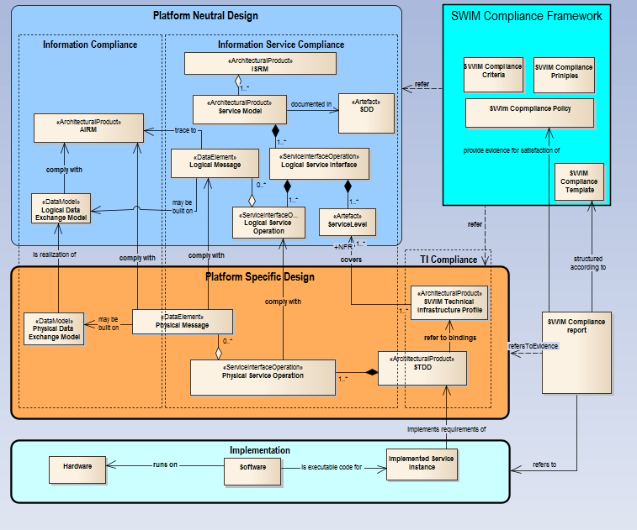
Figure 13: SWIM Compliance Framework

The SWIM Compliance Framework stipulates the rules and guidance to conduct compliance assessments for the objects under assessment (see preceding chapter). It consists of the SWIM Compliance Criteria (providing the criteria to achieve SWIM compliant services and artefacts), SWIM Compliance Principles (provides guidance on how to do compliance checks), the SWIM Compliance Policy (the document at hand) and the SWIM Compliance Template (template to generate compliance reports).

For every object under assessment a SWIM Compliance report shall be generated.

The SWIM Compliance Principles and Criteria documents exactly determine which artefacts of the SWIM Foundation Landscape [4] will be needed as means of compliance to generate a SWIM Compliance report.

As means of compliance the compliance reports will rely on:

- SDDs and the SWIM Service Design Rulebook for the assessment of the platform neutral service design
- STDDs and the SWIM TI Profile Specifications for the assessment of the platform specific service design
- Service Requirements and Service Quality requirements to assess the provision of SWIM Common Infrastructure Services (not shown in the figure).

    - Processes
      - Compliance Assessments
A compliance assessment is a process undertaken to asses
- the logical service design (platform neutral design) for compliance with the service design rulebook
- the service technical design (platform specific design) for compliance with the logical service design and the specifications of the TI profiles
- the provisioning of the SWIM Common Infrastructure services for compliance with the according service contracts.
The goal of a compliance assessment is to generate a compliance report which demonstrates the level of compliance of the assessed object. The following reports are needed:
- SWIM Compliance Report for platform specific SWIM Information Services designs.
- SWIM Compliance Report for platform specific SWIM Information Services designs and service instance implementations, which documents that those designs comply with the requirements of the logical service design.
- SWIM Compliance Report for the provisioning of SWIM Common Infrastructure services

      - Assessing the platform neutral SWIM Information Service Design
For a new logical service definition (or an update version of an existing one), the concerned ATM Stakeholder shall provide in accordance with the applicable regulations as stipulated by the current SWIM service design rulebook:
- Operational or business requirements and a justification that those requirements need to be implemented by a service.
- A description of the logical service design with a tracing to relevant service requirements.
- The SWIM Compliance Report with a justified proposal for the compliance assessment result.
The SWIM Authority is responsible to evaluate this material and provide the actual compliance level. In case of disagreement with the assessment result, the result dispute settlement can be activated by the concerned ATM Stakeholder.
      - Assessing the platform specific SWIM Information Service Design and the implementation of the service instance.
Prerequisites
Only service instances implementing an SWIM compliant technical service design description can apply for SWIM compliance. Therefore, if an ATM Stakeholder would like to apply for compliance for a given service instance for which there is not a SWIM compliant technical service definition present in the SWIM Registry yet.
Before creating a SWIM technical service design, an according SWIM compatible logical service design has to be available. If this is not the case, this needs to be produced. Refer to the SWIM Service Policy to determine how to create those.
For a new service instance, the ATM Stakeholder shall provide to the SWIM Authority a compliance report and all the information required for using such instance within the registry (please refer to the SWIM Service Policy) indicating the SDD and STDD that the service instance is implementing.
The compliance assessment of a new service instance can be done in two ways:
- Service Provider Self-Assessment
This means that the assessment report is generated by the service provider himself and handed over to the SWIM Governance Authorities to be approved by the governance authority.
- External assessment
A certified external assessor has to accomplish the assessment and handle the findings in cooperation with the service provider until the report reaches the state of approval. The next step after the approval would be to invoke the implementation coordination for the service activation.
How to determine the way of assessing
To differentiate between both assessment-approaches, a categorisation has to be provided.
This categorisation could be accomplished on the level of
- Service Providers (certified, not-certified)
- Impacted Consumers (number, business)
- Safety criticality of the supported business process
- Operational Impact (e.g. usage of the service in several business processes)
- Approached service quality
- …
This can lead to a decision matrix, which can indicate the appropriate kind of assessment.
The way how to determine the kind of compliance assessment is currently undecided. Since this is only an example or first draft of a compliance policy, not all of those questions can be answered. The concrete policy will need to be more explicit on this.
      - Assessing the provisioning of SWIM Common Infrastructure Services
The provisioning of a SWIM Common Infrastructure Service relies on a service contract concluded upon by the SWIM Governance Authority and the concerned service provider. The assessment of the SWIM Common Infrastructure is mainly a service monitoring. This can be done in two ways

            - Continuously or Regularly Benchmarks

- By technical means, using tools to simulate use cases for which the service has been implemented and measure the behaviour of a system or software. Those tools (possibly pre-defined by the governance authority to achieve a consistent view on the service quality provided by different providers) generate reports, which can be assessed. This could be done also by self-assessment, as the tool will keep the history and it will be possible for the governance authority to regularly track back to saved reports.

- By way of executing trials of the service itself regularly and generate a report manually (external assessment).

            - Intermittent
- By technical benchmarking where the governance authority demands the delivery in a sporadic, randomly manor. For this approach, the provider needs to regularly self-assess the service. The governance authority stipulates which tools will be used, how long the history needs to be kept and how often the provider has to assess the service.
- By way of trial the service randomly and generate a report manually (external assessment).

The concrete policy will need to be more explicit on this.
      - Compliance Result Dispute Settlement
The dispute on a compliance result can only be triggered for service design definitions, not for the service instance itself, as this inherits’ the compliance level of the implemented service definition
There shall be a process previously defined by the SWIM Authority for handling such disputes. It is assumed that the SWIM Authority will consist of several bodies, the one processing the compliance assessment requests not being at the top of the hierarchy. Therefore, it is assumed that an escalation mechanism will be possible inside the SWIM Authority.
With the current envisaged governance structure in mind [8] the SMU will be the governance point of contact for the service provider. The SMU will hand over the dispute the appropriate expert group if needed. A further escalation the SSG is possible if the dispute can’t be resolved on the lower levels.
      - Compliance Revocation
In addition to the expiration of the validity period, the SWIM compliance allocated to a given instance can be revoked if any ATM Stakeholder presents evidence to the SWIM Authority showing that such instance (Service Definition, Service Instance) does not fulfil the required compliance criteria.
There shall be a process previously defined by the SWIM Authority for handling such cases (please refer to the SWIM Service Policy).The process can lead to revoking the SWIM compliance to the concerned instance and to all other instances whose compliance depends upon (e.g. if the SWIM compliance is revoked for a given service definition, it will be also revoked for all Service instances implementing it).
    - Compliance Validity and Renewal Period
Any allocated compliance level is valid, and so, does not need to be renewed, until either:
- The compliance is revoked (see Compliance Revocation above).
- The Service Definition is deprecated (this will imply the end of the compliance validity to the Service Instances implementing it).
- A validity period is imposed by an updated version of the SWIM Compliance Policy or the SWIM Compliance Framework.
- The compliance is revoked as a result of a regulation from EASA or a NSA.
    - Compliance Applicability
The usage of the compliance policy is mandatory for SWIM service providers and the SWIM governance authority.
Unless otherwise stated by appropriate regulations (e.g. from EASA, NSAs, etc.), the SWIM compliance assessment is done on a voluntary basis but it needs to be noted, that without a SWIM compliance level assigned to a service, this service can’t be used operationally on SWIM.
    - Roles and Responsibility
The roles and responsibility regulations are elaborately described in the SWIM Compliance Principles document Error! Reference source not found..

    - Liability
The SWIM Authority is not liable for any consequence related to a declaration of compliance, even in the case when such declaration would be erroneous.
Declaration of SWIM compliance (even if erroneous) does not change the liability associated to the organisation declaring it.
    - Charging
Any party involved in a compliance assessment shall bear the costs of its own actions.
Note: The allocation of SWIM compliance to a given service does not impose any constraint on the charging conditions of the actual provision of such service.
    - Intellectual Property Rights
The compliance assessment of a given “Object under Assessment” may require the provision by the concerned ATM stakeholder (e.g., typically a service provider) of new definitions of:
- Service Logical Design Description Documents
- Service Technical Design Documents
- SWIM Profiles
- Change Requests to AIRM, ISRM, SWIM Profiles.
The ATM stakeholder having produced such new definitions shall allow them to be made openly available and its usage free of charge by any other ATM stakeholder. These new definitions, if accepted by the SWIM Authority, will be made available via the open domain of the SWIM Registry.
The SWIM Authority will not grant the SWIM compliance to any assessment that will not accept these conditions.
An exception to the previous statements on the requirements to have the new definitions being made openly available and published in the open domain of the SWIM Registry can be granted by the SWIM Authority in case it is duly justified for security reasons (e.g. for civil-military exchanges) by the military or a national/regional security agency.
The evidence produced and provided to the SWIM Authority in the context of a given compliance assessment will not be further distributed. The SWIM Authority shall be allowed to keep a copy of it for auditing purposes or for potential result disputes. Such provision to the SWIM Authority shall be done free of charge and will not imply any change on the evidence IPRs (i.e., the IPRs related to the evidence material are not transferred to the SWIM Authority).
    - Privacy
In addition to the provisions stated before, the result of a compliance assessment shall be published in the SWIM Registry (depending on the type of “Object under Assessment”, such results will be published either in the open or in the restricted domain).
There is an exception to the previous statement. In case the result of a given assessment is not compliant / lower or equal than the lowest possible compliance level, the ATM stakeholder having submitted the corresponding “Object under Assessment” can decide to:
- Have the assessment result being published in the SWIM Registry.
- Have the compliance result not published in the SWIM Registry (so, the corresponding “object under assessment” will show the compliance result as “In process”)
- Have the “object under assessment” entries deleted from the SWIM Registry.

    - Cross-conformance with other ICAO Regions
This topic is out of scope in the present version of the policy.

-END OF DOCUMENT-

To better clarify this and the previous bullet, further explanations are provided taken the Supervision (see [2]) as an example. It is assumed that all service providers will implement their own Supervision dealing with: Configuration Management, Fault Management, Performance Management, Security, Safety and Legal recording. This is considered to be a ‘Local’ IM Function. All the ‘local’ specificities of such supervision are not covered by the IM Functions described in this document. The Supervision IM Function depicted in the above figure as Governed function would only cover the items that would be defined in the Supervision Policy. Such policy might for example mandate that each ‘Local’ supervision shall distribute events to a ‘regional / central’ SWIM Supervision (if so stated in the policy).
Some of the objects under governance are under full control of the SWIM governance and therefore an internal CCB will be established to control their evolution. An internal CCB is an integral part of the SWIM governance organisation. Other standards are “external”, managed outside of the SWIM governance structure, but having a major impact on SWIM. There is a need to coordinate their evolution with external CCBs.
It should be noted that in general, most service implementations and updates will be co-ordinated between the service providers and their consumers.
A practical example could be the inclusion in the FO (or SO) network of a new server.
There were different views in the group responsible to produce this document regarding whether the Registry should have a dedicated IM Function for itself. Finally, it was agreed to have it considered as a service, but highlighting its specifics. .
This document does not cover any ‘local’ IM Functions (such as the local supervision) that need to be specifically addressed by service providers. The local supervision by the service providers should cover the major functional areas: Configuration Management, Fault Management, Performance Management, Security, Safety and Legal recording.
This document does not cover any ‘local’ IM Functions (such as the local supervision) that need to be specifically addressed by service providers. The local supervision by the service providers should cover the major functional areas: Configuration Management, Fault Management, Performance Management, Security, Safety and Legal recording. See also footnote 1.
It is reminded that, as indicated in the SWIM ConOps, the Use Cases are based on a number of assumptions. Therefore, the Use Cases (and their timeline) and the governing processes listed in this section have to be seen just as a proposal that might change in the actual SWIM deployment.
It has to be also noticed that the SWIM ConOps document provides in its Appendix A a detailed description of the different groups for a hypothetic SWIM governance structure. Such Appendix indicates the different tasks (functions) to be done by each of these groups. This is actually an approach other than what it is done here in the present document. In such Appendix of the SWIM ConOps, the first question answered is the ‘who’, and after the ‘what’ is indicated. In this IM Functions document, the emphasis in on the ‘what’, without considering the ‘who’ (except for a proposal done for the PCP/iSWIM deployment). Considering that the Appendix A in the SWIM ConOps is just a proposal subject to significant reservations from a number of ANSPs, it has not been tried to ensure full consistency between such proposal and the contents of this IM Functions document.
This diagram shows the formal process. However, new services can be put into operation before the compliance has been assessed. This is to enable agility between the implementation of new service instances and the ISRM/AIRM control.
It is not further specified within the use cases which governance body will be in charge. This can be detected by looking at the governing processes.
It has to be stressed that at the time of preparation of this document, the AF#5 iSWIM has been included in the SESAR Deployment as “Binding orientations”.
Therefore, it is not fully sure if funding would be available for the iSWIM deployment. For the purpose of this document, it will be assumed that iSWIM deployment will be funded by the EC as part of the PCP.
The precise information required will be defined in the corresponding EU regulation material.
Mainly the Service and the Compliance policies, although other defined policies – e.g. Information Security, Legal Aspects, …- will have also to be abode by.
As it has already been stated previously, this does preclude every service provider to implement their ‘local’ Supervision processes according to their ‘local’ practices and applicable regulations.
It should be noted that in general, most service implementations and updates will be co-ordinated between the service providers and their consumers.
There were different views in the group responsible to produce this document regarding whether the Registry should have a dedicated IM Function for itself. Finally, it was agreed to have it considered as a service, but highlighting its specifics. .
The value of the Document code field in the requirement identifiers has been set to “CONOPS” as it was considered the most appropriate one from the ones defined in the SJU guidelines. It has been ensured that the requirement identifiers in this document do not conflict with the ones in the SWIM CONOPS document.

